OSRADP Report #

Research and Development of a
Geographical Information System
of Petrochemical Transmission Pipelines
Between Baton Rouge and New Orleans, Louisiana

By
Robert L. Paulsell
Louisiana State University
Louisiana Geological Survey

For
Louisiana Oil Spill Coordinator’s Office/Office of the Governor

Oil Spill Research and Development Program

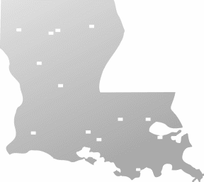

Research and Development of a
Geographical Information System
of Petrochemical Transmission Pipelines
Between Baton Rouge and New Orleans, Louisiana

Submitted to the
Louisiana Oil Spill Coordinator’s Office/Office of the Governor
Oil Spill Research and Development Program

By
Robert L. Paulsell
Louisiana Geological Survey
Louisiana State University

Disclaimer

This report was prepared under a contract between Louisiana State University and the Louisiana Applied Oil Spill Research and Development Program (OSRADP). The contents of this document do not necessarily reflect the views and policies of the Louisiana Oil Spill Coordinator’s Office—Office of the Governor or that of the Louisiana Applied Oil Spill Research and Development Program or that of Louisiana State University nor does mention of trade names or commercial products constitute endorsement or recommendation for use by the state of Louisiana.

Report Availability

Additional copies of this report may be obtained by writing to:

The Louisiana Applied Oil Spill Research and Development Program
2008 Deliverables
Room 258 A Military Science Building
Baton Rouge, Louisiana 70803
Telephone number: (225) 578-3477 • FAX number (225) 578-0403

Or from

The Louisiana Oil Spill Coordinator’s Office/Office of the Governor
Natural Resources Building
625 N 4th Street, Room 800
Baton Rouge, Louisiana 70804
Telephone number: (225) 219-5800 • FAX number (225) 219-5802

Citation

Suggested Citation:

Paulsell, R.L. 2008. Research and Development of a Geographical Information System of Petrochemical Transmission Pipelines between Baton Rouge and New Orleans, Louisiana: Louisiana State University, Louisiana Geological Survey. Louisiana Applied Oil Spill Research and Development Program, OSRADP Technical Report Series.

Table of Contents

Abstract 1
1.0 Introduction 3
1.1 Background 3
1.2 Objective 6
1.3 Data Standards 7
2.0 Methods 8
2.1 Outline of Methods 8
2.2 GPS Point Data Integration 8
2.3 GPS Data Collection 10
2.4 GPS Point Data Analysis 11
2.5 Pipeline Commodity Descriptions 11
2.6 Pipeline Feature Development 15
3.0 Industry 16
3.1 Pipeline Operators 16
3.2 Industry and Pipelines 16
4.0 Conclusions 22
5.0 References 23
6.0 Appendices (Tables) 25

List of Figures
Figure description page
1.1 Study Area 3
1.2 Spatial Problems with Data 5
2.1 Typical pipeline warning signs 9
2.2 GPS data post processing results 9
2.3 GPS points data collected 11
2.4 Mileage graph of commodities transported 14
2.5 Pipeline feature development 15

List of Tables

Table description page
6.1 Database definitions for attribute tables developed in project 25
6.2 Pipeline operators with emergency contact telephone numbers 26
6.3 Commodities shipped by operator 28
6.4 Pipeline mileage 30

Acknowledgements

The investigator would like to thank the pipeline operators and agencies that have contributed data to this project. Also, I would personally thank Mr. Roland Guidry, Louisiana Oil Spill Coordinator; Dr. Don Davis, OSRADP Director; Ed Flynn, Louisiana Chemical Association, for their assistance in notifying the public, industry and government agencies of our mission.
Special thanks go to the industries located within the study area. Their cooperation and patience are greatly appreciated.
Also, I would like to thank Pat O’Neill of the Louisiana Geological Survey for his assistance in collecting GPS point data.

Research and Development of a
Geographical Information System
of Petrochemical Transmission Pipelines
Between Baton Rouge and New Orleans, Louisiana

Abstract

This project is intended to enhance emergency response and planning to possible pipeline incidents with spatially accurate digital data covering hazardous petrochemical transmission pipelines located within an area between Baton Rouge and New Orleans (Figure 1.1). The development of a digital pipeline inventory for the state of Louisiana has been underway for several years. These data will give first responders access to sensitive pipeline data allowing for rapid incident response. Also, dispersion models can be applied to pipeline features to show the speed and spread of contaminants throughout communities and ecosystems.
The original estimate of 2,000 miles of pipelines to be mapped within the study area was very conservative. Roughly 6,202 total miles of pipeline features are within the revised study area. 4,027 miles of new polyline features were developed in this mapping project. Updated pipeline features include East Baton Rouge Parish and the Greater New Orleans area with a combined 2,175 miles of transmission pipelines. Development of digital petrochemical pipeline data is crucial for energy planning, environmental monitoring, disaster prevention, and especially emergency preparedness/response.
Pipelines are the safest, cleanest and most economical means to move natural gas, petroleum and petroleum products from the extraction point to the final consumer. They are the only feasible means to transport the vast quantities of petroleum and natural gas throughout the nation. However, damage to pipelines can be dangerous to the environment and public. Consequences of pipeline failures include explosions or inhalation hazards causing injury or even fatalities. Many products transported by pipelines are colorless, tasteless and odorless making leak detection by the public difficult. Detection of pressure anomalies are the usual means of leak detection by pipeline operators. These anomalies are usually detected quickly at pipeline system control centers and the pipeline can be shut down within minutes.
Many of the commodities transported by pipelines are heavier than air and tend to “pool”, posing asphyxiation hazards. Also, when mixed with the right amount of air, these volatile compounds can pose an explosive hazard. Hazardous liquids leaks can migrate through the permeable geology that lies beneath the study area and into aquifer systems. Sensitive ecosystems are vulnerable to the effects of these organic compounds as are humans. Crude or refined product spills can cause extensive environmental and property damage. Most pipeline operators have trained personnel and specialized equipment to handle spill responses.
There are many causes of pipeline failure. The leading causes for pipeline spills are corrosion and improper excavation around the pipeline. “Combined data indicate that “outside force” damage contributes to a larger number of pipeline accidents and incidents than any other category of causes…The data show that for hazardous liquid pipelines and gas transmission pipelines, the largest portion of outside force damage results from excavation damage. The range of excavation damage runs from damage to the external coating of the pipe -- which can lead to accelerated corrosion and the potential for future failure -- to cutting directly into the line and causing leaks, or, in some cases, catastrophic failure.” (U.S. Department of Transportation, Office of Pipeline Safety Communications: Pipeline Failure Causes, http://primis.phmsa.dot.gov/comm/FailureCauses.htm. OPS Incident Overview for 2007 lists 5 hazardous liquid pipeline incidents and 15 gas transmission pipeline incidents reported in Louisiana. Although the numbers of incidents are down from 2006, there were two fatalities and one injury due to gas pipeline incidents. Damages upon hazardous liquids pipeline initially caused a loss of 538 gross barrels of liquid commodity. Roughly 400 of those barrels were recovered, http://primis.phmsa.dot.gov/comm/reports/safety/LA_detail1.html#_ngtrans. Over 18.5 million dollars in damages resulted from all Louisiana pipeline incidents.
There are several categories of pipeline failures. These include corrosion, excavation accidents, material failure, human error and natural forces. Pipeline operators have developed technologies to reduce or eliminate corrosion and material failure. Cathodic protection techniques and improvements in pipeline coating materials are reducing the effects of corrosion and failure. Also, smart pigs are used to detect anomalies in the pipelines that are a result of corrosion or defective materials. The pipeline failures that result from excavation accidents or other human error can only be reduced or eliminated through thorough training and use of one call systems (http://www.laonecall.com/main_frame_page.htm), dial 800-272-3020 for Louisiana One Call or 811 nationwide.
For more information on pipeline safety please refer to the “Pipeline Inspection, Protection, Enforcement, and Safety Act of 2006” enacted by the US Congress December 7, 2006 (HR 5782). Also, for spill response planning and preparation, see the National Contingency Plan which outlines the structure and priorities for spill response at the federal, state, local government level as well as company level (Code of Federal Regulations, Title 40, Ch. 1, subchapter J).
Accurate digital pipeline maps with object-oriented relational database will enable increased emergency response and energy planning efficiency by allowing oil spill responders and researchers to quickly assess diameter, commodity transported, operator, and emergency contact telephone numbers of specific pipelines. Emphasis in this project is on transmission pipelines rather than those associated with gathering or distribution systems. Generally, the investigator mapped pipelines with diameters of four inches or greater. Pipelines with diameters less than four inches in diameter were mapped where spatial confidence was high and reference data were available.
A method to digitally verify and/or create pipeline features has been developed by the Louisiana Geological Survey (LGS). Utilizing Global Positioning System (GPS) technology, point data were collected at pipeline warning sign locations that were observed near pipeline crossings of public roads. These GPS records contain accurate positional data, pipeline operator, and commodity transported by the pipeline. These point data were compared to existing hard copy maps and digital pipeline data. Pipeline features were developed with heads up digitizing techniques utilizing aerial and satellite imagery, GPS point data, digital and hard copy maps or diagrams submitted by operators, and reliable third party maps.
Through detailed source data research, field investigation with GPS, remote sensing, and GIS analysis, a method to develop pipeline features or to adjust any spatially incorrect data will result in a comprehensive petrochemical pipeline GIS for the area in between Baton Rouge and New Orleans, Louisiana. The data developed for this project is intended for emergency response as well as environmental and energy planning.

- Introduction

  - Background

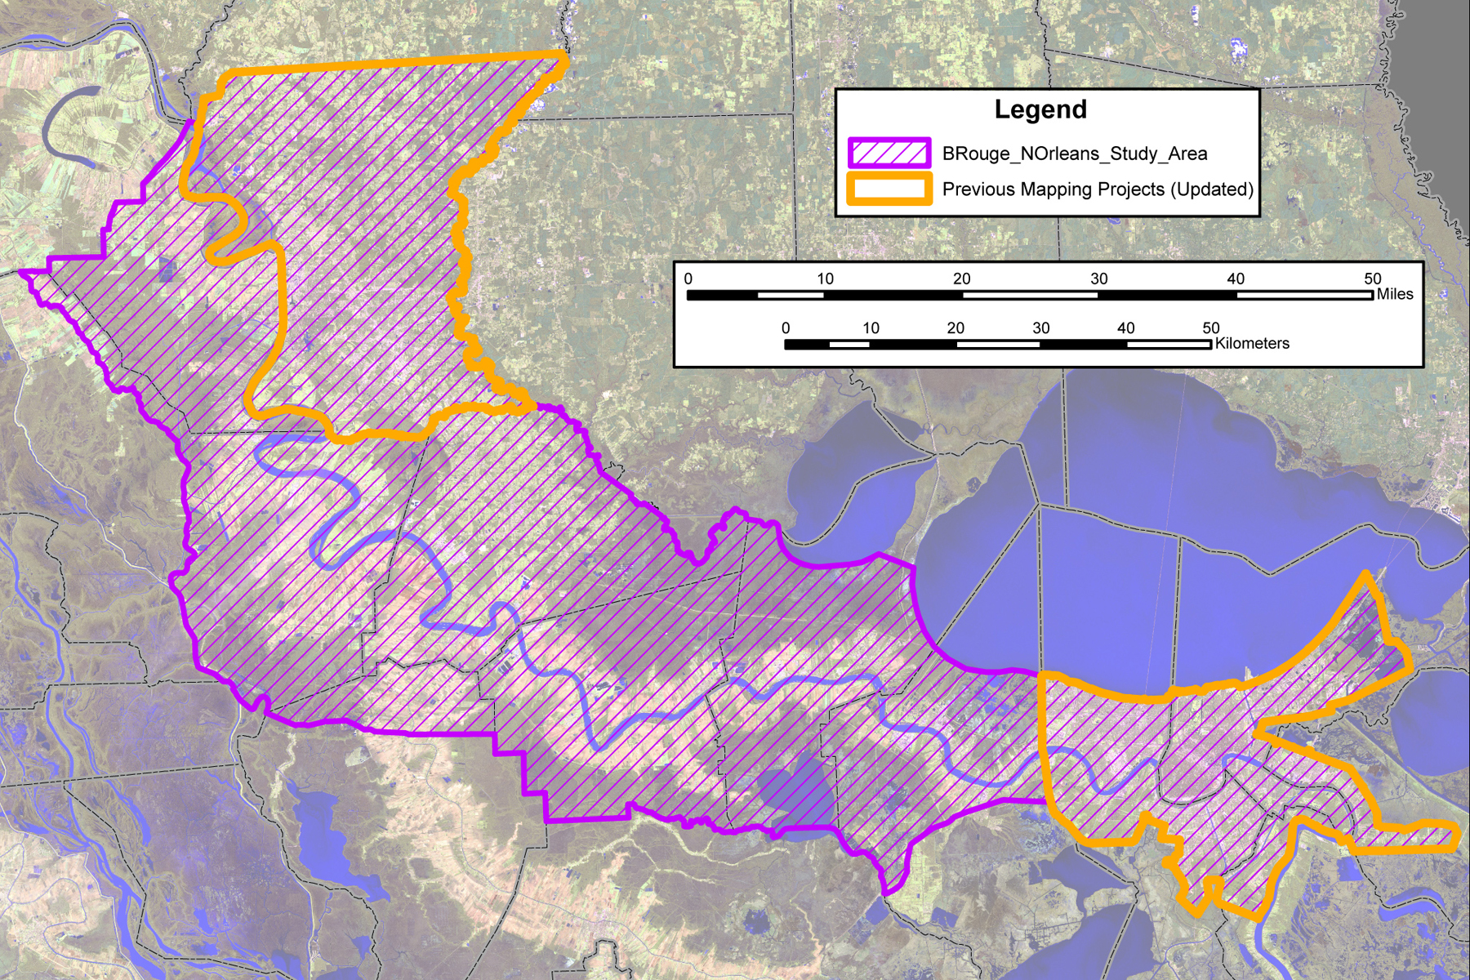
The discovery of oil and gas in southern Louisiana signaled the beginning of the petrochemical industry along the Mississippi River. The proximity of natural resources combined with the necessary transportation infrastructure and plentiful fresh water supply allowed for rapid industrial development along the river between Baton Rouge and New Orleans, Louisiana. Associated industries, such as air separation/reduction and organic chemical production, have symbiotically emerged with refineries along the river. To supply these plants with the needed fuels and manufacturing material, a network of pipelines has been developed. Raw material such as crude oil and natural gas are transported through these conduits to refineries. The downstream or post refinery pipelines carry petroleum and natural gas products to nearby plants for further processing or use as feedstock. The 6,202 miles of pipelines that lie within the 2,302 square mile study area (Fig.1.1) constitute a potential leak or spill incident that could adversely affect nearby natural and human communities.
Figure 1.1 Pipeline mapping study area

If you know or suspect that a pipeline is leaking or damaged, your personal safety and the safety of those around you should be your first concern. You should follow these steps:

1. Leave the area immediately and warn others to stay away.
2. Avoid direct contact with the escaping liquids and/or gases.
3. Avoid driving into vapor clouds.
4. Avoid creating sparks or sources of heat which could cause liquids or vapors rising from them, to ignite and burn. For example, cellular telephones, lighters, flashlights, vehicle ignition, two-way radios, light switches, garage door openers, etc.
5. Turn off any running machinery (engines); do not attempt to move the equipment. Shut the equipment off and leave the area.
6. Call the pipeline operator (emergency number on warning sign) from a safe location.
7. Give your name, phone number and a description of the leak and its location.
8. Call the local emergency response agency.
9. Do not attempt to shut off any valves or extinguish any fires.

Some signs of a petrochemical/gas pipeline leak include but are not limited to:

1. Blowing or hissing sound
2. Dust blowing from a hole in the ground
3. Continuous bubbling in wet or flooded areas
4. Gaseous or hydrocarbon odor
5. Dead or discolored vegetation in an otherwise green area
6. Flames, if a leak has ignited
7. Pool of liquid near a pipeline or sheen on water
8. Dense cloud or fog over a pipeline

The contents of a petrochemical pipeline may be gaseous or liquid, both under high pressure. These products may be colorless and/or odorless. While some gases are lighter than air and will rise into the atmosphere, other heavier than air gases or liquids will pool near low areas. All petroleum gases and liquids are flammable and can also pose asphyxiation hazards. Other non-flammable and/or hazardous materials are also transported by pipeline, such as anhydrous ammonia, acids, carbon dioxide, chlorine, and brine to mention a few. These lines are under high pressure and can cause sever injuries or worse if damaged. In accordance with state and federal law, Louisiana One Call must be contacted at least 48 hours prior to any excavation. In certain parishes, the time span has been increased to 96 hour notification prior to excavation (call 800-272-3020 or 811 nationwide, see http://www.laonecall.com/main_frame_page.htm). Keep in mind, many pipeline operators are not members of Louisiana One Call or some members do not list their emergency contacts.
The Louisiana Geological Survey (LGS) has been developing digital pipeline data within the state for a statewide pipeline digital inventory for many years. Numerous maps and other geographic data concerning pipelines have been collected and cataloged. Most of these data have been in hard copy format, maps and other diagrams submitted by pipeline operators. Many of these submissions have poor spatial control and are not suitable for input into a GIS. These maps were helpful reference materials with the development of pipeline features in this study. Documentation on pipelines is difficult to acquire due mostly to the attacks on the United States by terrorists.
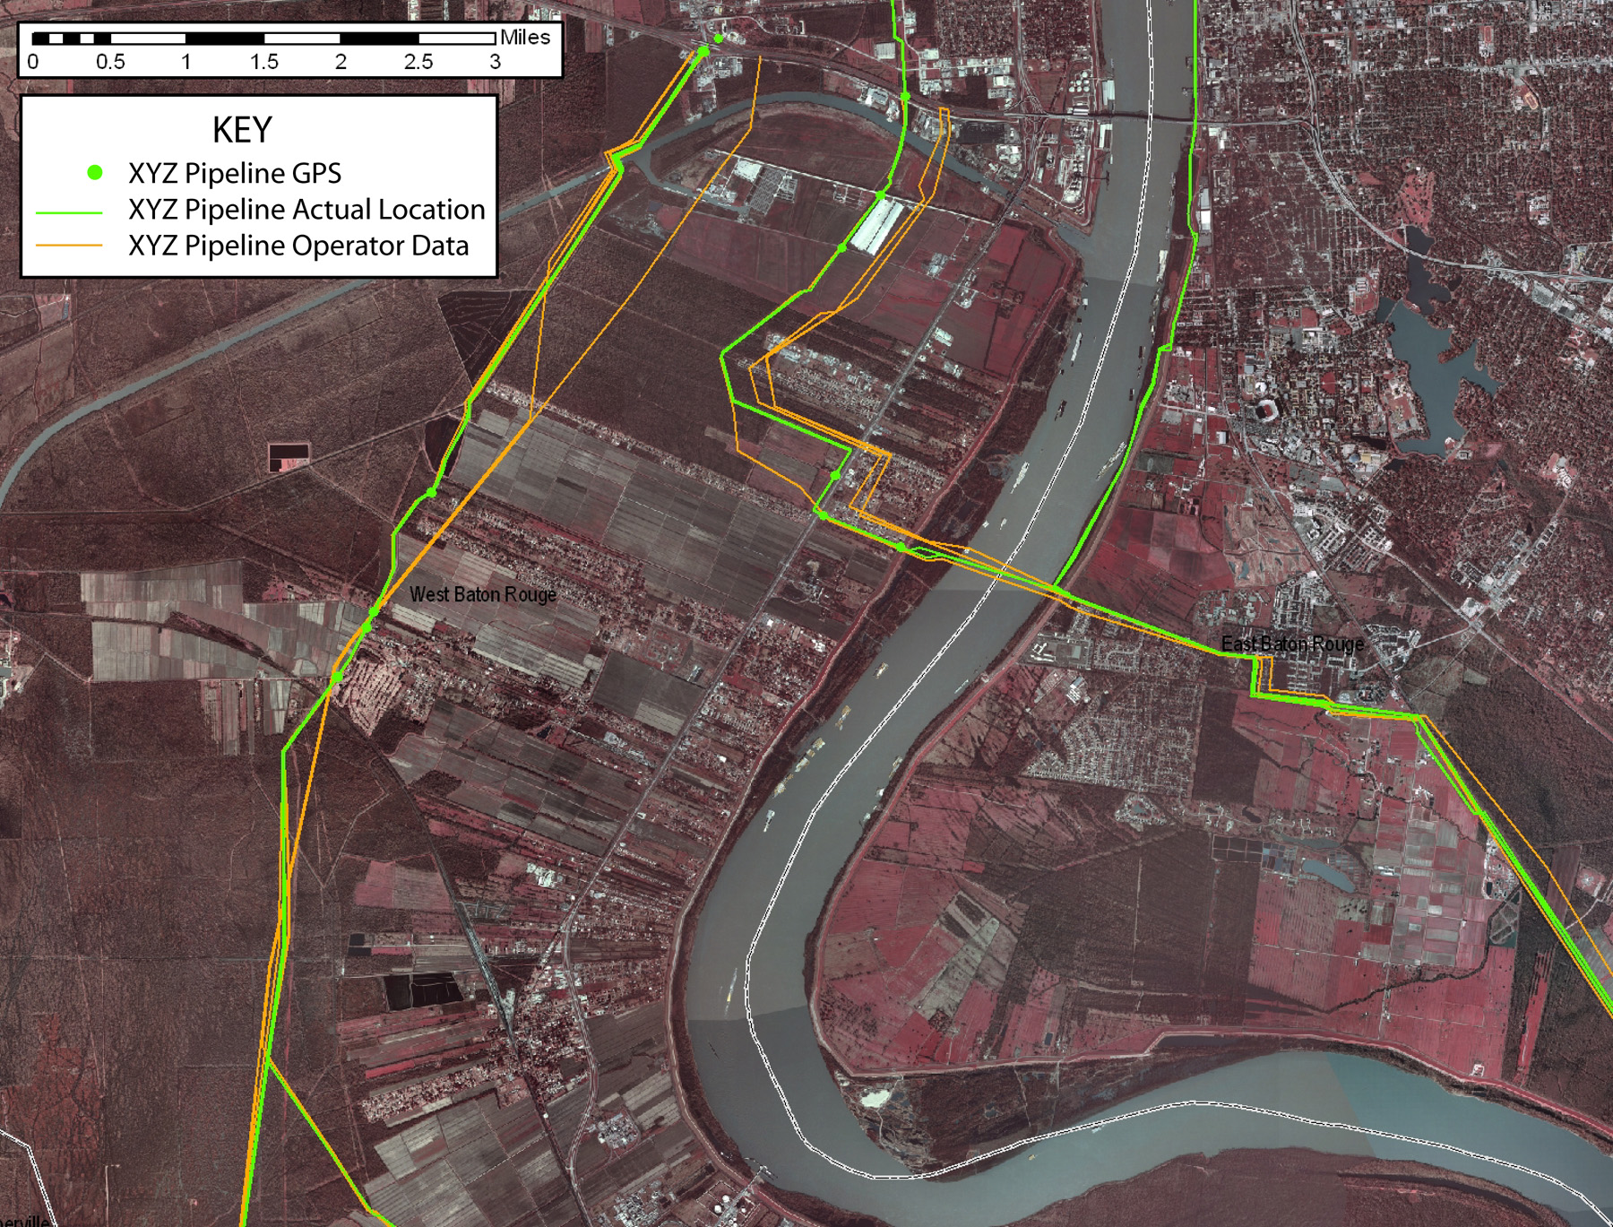
Other digital data used as reference were acquired from the Federal Office of Pipeline Safety, National Pipeline Mapping System (NPMS) pre-September 11, 2001. The Louisiana Geological Survey was an active state pipeline data repository during the development of the NPMS. Pipeline operators were required to submit spatially accurate pipeline data to either the national or state repositories. These data were to conform to certain standards that leave a considerable amount of margin for error (see standards, section 1.3). Generally, most of the data submitted by pipeline operators have very good spatial quality, however, some data were found to contain substantial spatial errors (Figure 1.2). Some hard copy map data have proven difficult to incorporate into a GIS for the lack of adequate spatial control on the map. Spatial control allows for accurate input into a digital format. The various types of data submissions, digital and hard copy, have both displayed multiple problems. Ironically, the spatial problems displayed by some operators’ digital data were similar to the spatial problems displayed by data digitized at the LGS. Apparently the same maps were digitized by different people and displayed the same spatial problems. The focus of this study is to acquire GPS point data of pipeline intersections of primary and secondary public roadways and compare these data to available digital pipeline data and other maps and aerial imagery. Through this process, we are able to develop a comprehensive pipeline GIS for the study area.
Figure 1.2 Pipeline operator data can display spatial problems.
Some pipeline operators have not submitted any data to the LGS or the NPMS. These are mostly intrastate operators that were not required to submit data to the NPMS effort. Developing digital data for these operators is challenging but achievable through intensive data research. Many operators will include reference pipelines on their engineering diagrams and maps. These lines are helpful in spatial alignment of undocumented pipelines. Also, several unknown operators have small systems that were purchased or separated from larger companies whose pipelines are well documented. Mergers and acquisitions are many and often causing confusion in determining the current operator of pipelines.
The development of digital pipeline data for this project is done uniformly for all operators emulating guidelines established by the NPMS. Data developed for this project include intrastate pipelines as well as interstate. The inclusion of emergency phone numbers, comments, and a digital copy of the 2008 Emergency Response Guidebook (2008 ERG, a guidebook for first responders, DOT/RSPA http://hazmat.dot.gov/gydebook.htm) greatly enhance the data. The NPMS data do not contain emergency contact telephone numbers. This information is an important tool for emergency response to a pipeline incident. The data developed in this project can be loaded into emergency response databases and quickly accessed. Our first responders need the most accurate and up to date data for their and public safety.
Much concern has been placed on pipeline safety and the Department of Homeland Security considers pipelines as part of our critical national infrastructure. The USA Patriot Act defines critical infrastructure as, “systems and assets, whether physical or virtual, so vital to the United States that the incapacity or destruction of such systems and assets would have a debilitating impact on security, national economic security, national public health or safety, or any combination of those matters” (The National Strategy for the Physical Protection of Critical Infrastructures and Key Assets, Feb 2003, http://www.whitehouse.gov/pcipb/physical.html). Among the guiding principles of our domestic protection are two important challenges that this project attempts to address. First, there must be a “partnering among all levels of government and industry”.
Our efforts to acquire pipeline data from operators have been fairly successful. However, requests for data in this project seem to have been mostly ignored. Of 70 letters sent to industry within the study area, only one pipeline operator responded with data. One pipeline operator manager called indicating a desire to cooperate, only to be refused by his GIS group. One email from a power plant indicated cooperation; however, the gas supply pipeline is operated by another party. Most of the 70 notifications had no response. Many operators honored prior requests for data in the 1990’s, thus did not need to respond. Those data submitted to the LGS have been mostly hard copy maps submitted prior to September 11, 2001.
The guiding principles of the national strategy indicate that “we must also develop and facilitate reliable, secure, and efficient communications and information systems to support meaningful information sharing among various public and private sector entities”. To better serve and protect the public and industry, a complete and up to date inventory of the states’ pipeline network must be developed. Pipelines are vulnerable to threats of terrorism and natural disaster. A pipeline GIS would allow for rapid assessment of transported commodities, diameters, and emergency operator contacts as well as facilitating rapid plume modeling for atmospheric and subterranean dispersion of contaminants. Also, the GIS, when complete, “…will facilitate protection planning, decision making, and resource allocation”.

  - Objective

The objective of this project is to collect all pertinent pipeline documentation, to collect and compile GPS point data on transmission pipelines crossing of public roads, and developing a petrochemical pipeline GIS for the “chemical corridor”. Included in the GIS will be vector pipeline features (shapefile format, ESRI Inc., Redlands, CA) with a data structure similar to that created by the National Pipeline Mapping System (NPMS) (Table 6.1). Additional supplemental data will identify industrial sites with plant manager, contact information, and plant activity. Future efforts can include other value added development to the pipeline database. Fields can be added to the databases to incorporate Facilities Management (FM) data such as pipeline casing materials and ages, geological and/or environmental hazards, and links to other files or websites. For now, the D_link field in the database is linked to the 2008 ERG.
Creating a GIS of hazardous materials pipelines is detail intensive. Evaluating the existing digital and hard copy data submitted by pipeline operators was first on the list of many tasks. Digital as well as traditional hard copy maps were intensively examined to determine the spatial integrity of pipeline data. Third party maps were very useful in determining location, diameter of the pipe, and commodities transported of many pipelines. Data standards were adopted from the NPMS for our pipeline mapping efforts. Details on the standards can be found in the following section.

  - Data Standards

The U.S. Department of Transportation, Office of Pipeline Safety had created the National Pipeline Mapping System to “support the development of a reasonably accurate digital pipeline system” (www.npms.rspa.dot.gov or http://primis.phmsa.dot.gov/comm/Index.htm). The standards for data submission created by the NPMS allow for no more than a 500 foot margin of spatial error for digital pipeline data. The LGS has adopted these guidelines for our pipeline GIS development, but is striving to develop data that are within 50 to 100 feet of true spatial location. The standards request data provided to be in digital format with accompanying metadata. If digital data are not available, then the operator may submit hard-copy data. All submissions are to contain geospatial data (location data), attribute data (descriptive information), and metadata (description of the content, quality, condition, and other characteristics of the submitted data).
The coordinate system used is based on the North American Datum (NAD) 1983. Unprojected data that employs a common projection, such as Universal Transverse Mercator (UTM), will be accepted. Digital data that does not employ real world coordinates cannot be accepted. These would include CAD files that have origin points of 0,0. Measurement data can be metric or english units. Base maps used to develop the digital data should have scales of 1:24,000 to 1:1,200. The spatial accuracy of the digital data should be stated in the accompanying metadata. Many operators state accuracy of better than 100 feet, when, in fact, their data has been found to be 1,500 feet or more off.
The digital submissions should be of the following formats, ESRI’s Arc/Info .E00 export files, ESRI’s ArcView shapefiles (.shp), Intergraphs FRAMME and .DGN formats, MapInfo .mif files, and AutoCAD .dwg with required attribute data.
Hard-copy data submissions are accepted, using appropriate base maps, in the following formats. USGS topographic maps, 7.5 minute/1:24,000 scales are the preferred base maps. Pipeline inventory and alignment sheets are acceptable if they have a scale between 1:24,000 and 1:1,200 and contain a minimum of four georeferenced control points per sheet. Also, any third party base maps can be used if the above scale and control parameters are followed. These third party maps must also include projection parameters, datum, and graphic scale in order to be acceptable.
Unfortunately, the LGS is no longer an active part of the NPMS and have received little data from pipeline operators since the late 1990’s. We do have extensive hard copy maps that were submitted by operators in the early 1990’s, but much of these do not meet the submission standards mentioned above. The NPMS data are not available for download and have displayed problems with spatial accuracy. These data should be field verified for quality control.

2.0 Methods

The following outline describes the methodology in the pipeline feature development.

2.1 Project Method Outline

I Data collection route planning
A) Develop preliminary GIS populated with data from LaGIS CD
B) Study existing data for potential stops (design a route plan)
C) Examine aerial imagery for confirmation or other stops
D) Review traffic scenarios
II GPS data collection and compilation
- Compile data dictionary (list of operators and commodities)
- Complete route plan (collect GPS data)
- Ensure all data is collected and documented thoroughly
III Data projection and conversion
- Upload GPS point data to GIS
- Export features as ArcGIS Shapefile
- Load shapefiles into ArcGIS Project
IV Spatial feature GIS overlay and analysis
- GPS point data theme
- LGS digital pipelines theme
- Other digital pipeline data
- DOQQs and other themes from LaGIS CD to aid in analysis
VII Assess spatial accuracy of digital pipeline data
- Load digital point and linear pipeline data per operator into one view
  - GPS point data shapefiles developed per operator/commodity
  - Pipeline features, LGS and NPMS, per operator
  - Analysis unique to each operator and commodity
- Develop pipeline features utilizing heads up digitizing
V Database normalization and quality assurance
- Populate and review digital attribute tables
- Ensure database integrity (Quality Control)
- Create metadata
VI Create DVD containing GIS files and report

2.2 GPS Point Data Integration

The use of Global Positioning System (GPS) technology for the assessment of pipeline data quality has been of great value. The LGS has collected GPS point attribute data for pipeline crossings on primary and secondary roads within the study area. Since pipelines are usually buried, warning signs are used to indicate their presence along the pipeline route (Figure 2.1). Markers and warning signs are located at intervals along pipeline rights-of-way (ROW). They are found where a pipeline intersects a roadway, railway or waterway, and at other prominent points along the route such as valve stations. Markers indicate that a pipeline is in the area; they usually identify the product transported in the line, and provide the name of the pipeline operator and a telephone number to call in the event of an emergency. Pipeline locations within a ROW may vary both horizontally and vertically (depth), and the pipeline may not follow a straight course between markers. Additionally, there may be multiple pipelines located in the same ROW. Some operators mark the edges of the pipeline ROW with the warning signs while other operators place signs as close to the pipeline as possible.

Most of the recorded data were found upon pipeline warning posts that are placed above the buried pipelines. These include, but are not limited to, operator name, commodity transported, diameter of the pipeline, and emergency telephone number. Most warning posts have the operator, commodity, and phone number listed. However, few of these warning signs have pipeline diameters listed. GPS point data were collected as close as possible to warning sign locations. The GPS data are used to verify digital pipeline spatial integrity and for pipeline feature development. Most warning signs are in plain view and well labeled.
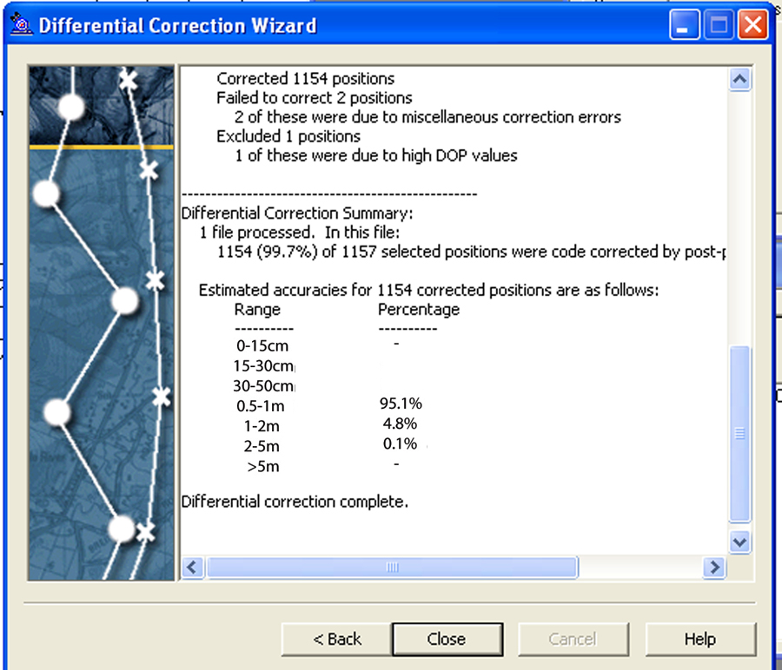
Other data are automatically recorded when logging data into the GPS. These include GPS time and Position Dilution of Precision (PDOP). The PDOP is calculated to show predicted accuracy of the recorded data. GPS positional errors can result from atmospheric interference and poor satellite geometry. Other sources of error in GPS data are multipath reflections of GPS signals, such as bouncing off buildings, and electronic interference, as with power lines. Over 90% of the collected data were free of these interferences. Also, the GPS receivers were set to average a minimum of five points per location. This “averaging” technique allows for more accurate spatial positioning by calculating the median geometry of five or more points per record. Differential correction (DGPS) was applied to the GPS point data upon return from the field for further positional refinement. Post processing for DGPS involves downloading base station files for applying mathematical formulas to “correct” any spatial errors in the collected data (Figure 2.2). Several Continuously Operating Reference Station (CORS) were used to correct the collected GPS data. Utilized CORS facilities were LSU Center for GeoInformatics (LSU-BR), SJB Group (Baton Rouge, LA), English Turn (LA), and Houma (LA).
Figure 2.1 Typical pipeline warning signs
Great effort was taken to place the GPS antenna directly over the pipeline being mapped and as close as possible to the warning sign. Collected GPS data were loaded into the GIS and compared to digital pipeline data. The accuracy of the GPS data, after differential corrections were applied, was mostly sub meter.
Figure 2.2 GPS point data post processing results.
Digital photographs were taken for reference at many stops. These photos were especially useful in resolving problems with pipeline feature development. The digital photos aid in clarifying areas with pipeline clusters or where hazardous data collection conditions exist causing incomplete data recording. These photos will not be published and are not available to the public.

2.3 GPS Data Collection

The geographic parameters used in data collection and development are Universal Transverse Mercator (UTM) coordinate system, zone 15, NAD 83 datum. The GPS point data were collected using Trimble Geoexplorer III and GeoXT GPS receivers (Trimble Navigation, Sunnyvale, CA) and uploaded to computer via Trimble Pathfinder Office software. The Pathfinder Office software allows for the development of a data dictionary, a custom file containing operator name, commodities transported, satellite geometry, pipeline diameters, or any other list data deemed important. This file is scrolled through to the desired field definition when recording point data. Collected data is exported from the Trimble Pathfinder Office software as shapefiles, the format used by the GIS software utilized in this study (ArcGIS 9.1, ESRI Inc., Redlands, CA). Recording spatial data on hard copy forms serves as a backup data source. Thus, pipeline attributes are recorded twice; once in the GPS and duplicative on hard copy forms (time stamp as a relational key).
One of the most difficult issues to resolve in data collection was the many corporate mergers, acquisitions, and divestures in the pipelines industry. Many observed witness posts did not match any digital or hard copy data. Likewise, several point data collected on one road did not match data collected on a parallel road. This problem is most prevalent on rural roads. Major arterial roads are likely to have new signs placed after mergers and/or acquisitions, unlike many rural roads. Adjustment for these discrepancies comes with time and experience.
Some remote data were recorded solely on hard copy field forms. The emergency telephone numbers were difficult to key into the GPS datalogger and were added to the respective tables in the office. Occasionally, encounters with unknown or undocumented pipeline operator witness posts caused problems with documentation. These had to be recorded in the GPS as unknown and well documented on field forms and digital photos. The GPS data dictionary is constantly revised to reflect all pipeline operators observed within the study area. Some 67 pipeline operators were investigated in this phase of the project. Some of these pipeline operators are subsidiaries of others, due to mergers and acquisitions, but have different emergency contacts.
On occasion, poor satellite geometry or other interference would inhibit GPS data collection. This is most apparent when surrounded by buildings, trees or other obstructions. Multipath interference, reflection of satellite signals off obstructions, could affect GPS point data quality. Accuracy in point data collection is important, especially where pipelines are clustered in groups. Each pipeline was recorded in the GPS data collection unit, with each pipeline, commodity, emergency phone contact, time, and road/location also recorded on hard copy forms.

2.4 GPS Point Data Analysis

Upon completion of field investigations, the over 4,000 collected GPS points were loaded into the GIS for analysis and pipeline feature development (Figure 2.3). This was accomplished by first creating unique pipeline and GPS point attribute files per operator. GPS data were exported unique to commodity per operator for pipeline feature development. Many pipeline warning posts vary in their labeled commodities. Many of the observed posts were clearly labeled with a specific commodity, such as natural gas, crude/petroleum, or ethylene. However, most signs are labeled with generic descriptions such as LPG (Liquefied Petroleum Gas), HVL (Highly Volatile Liquid), and NGL (Natural Gas Liquids).

2.5 Pipeline Commodity Descriptions

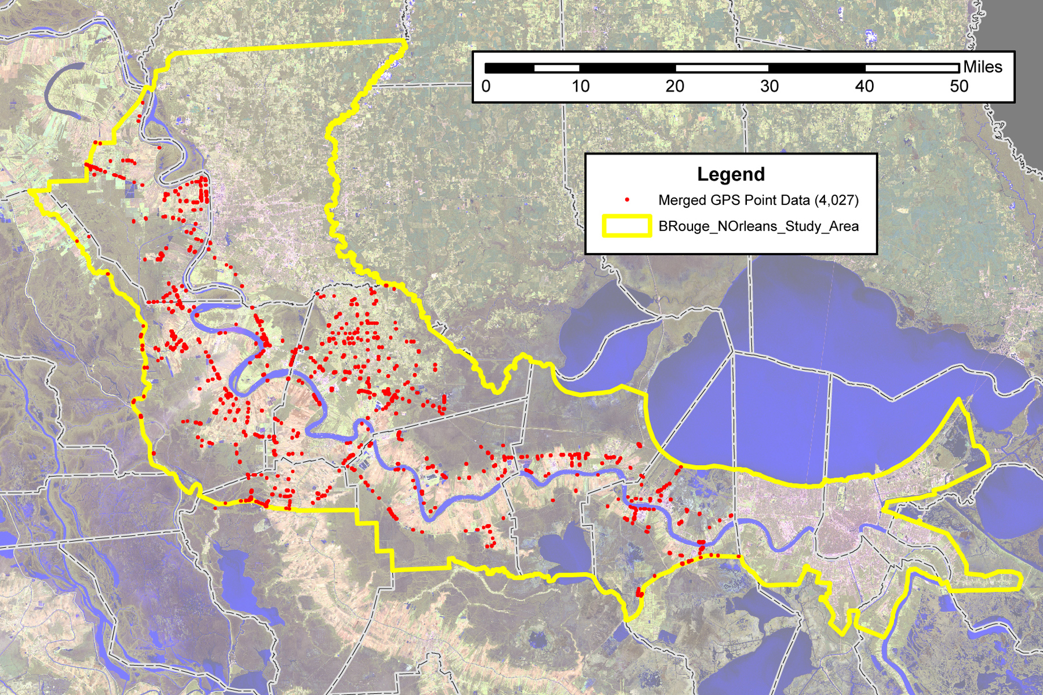
The following briefly discusses the contents of pipelines as witnessed upon warning signs within the study area. Certainly, there are more commodities transported through pipelines in the study area than are described here, however, this will give an idea of the importance of pipelines.
LPG is a complex combination consisting primarily of saturated aliphatic hydrocarbons ranging from C1 to C12 that are vapors at normal temperatures and pressures. This mixture of hydrocarbon gases is used as fuel and chemical feedstock in industrial applications. Industry has also increased usage of LPG for aerosol propellant and as a refrigerant. It is either extracted from oil or gas streams at the wellhead, or it is synthesized during the refining process. Primary LPG commodities include propane and butane, with propylene and butylenes present in small quantities. Other chemical names for LPG are LP Gas, Y-Grade, Demethanized Gasoline, “Raw Feed", Demethanized “Raw Feed Mix”. LPG has a higher colorific value than natural gas and must be mixed with air to provide for similar combustion characteristics. Similarly, refrigerant grade LPG is nearly pure propane (with odorant) with a high flash point.
Figure 2.3 GPS point data collected, note the lack of data in inaccessible areas (GPS data for E. Baton Rouge Parish and the New Orleans area previously collected)
Natural Gas Liquids (NGL) are natural mixtures of gaseous hydrocarbons found in the ground or obtained from specially driven wells. NLG’s are complex combinations consisting primarily of saturated aliphatic hydrocarbons ranging from C4 to C12. Its chief component, methane, usually makes up from 80% to 95% its composition. The balance is composed of varying amounts of ethane, propane, butane, benzene, cyclohexane and other hydrocarbon compounds. Other chemical names for NGL are Natural Gasoline, Casinghead Gasoline, Condensate, Drip Gas, “M” grade. NGLs and LPGs are commonly referred to similarly.
Highly Volatile Liquids (HVLs) are flammable or toxic fluids, which are gases at ambient conditions. These fluids can be anhydrous ammonia, naphtha, propane or any “condensed” hydrocarbon. Many observed warning signs throughout the study area are labeled with this generic type of commodity description. It is commonplace for several commodities to be transported through a pipeline. Thus to label the commodities transported on a warning sign, perhaps the pipeline operators use broad terms to describe pipelines’ diverse contents. HVLs, as defined in 49 CFR Part 195, are hazardous liquids which form a vapor cloud when released to the atmosphere and which have a vapor pressure exceeding 276 kPa (40 psia) at 37.8 degrees C (100 degrees F)."
Primary commodities transported by these pipelines were identified with references such as hard copy map data submitted by operators, digital NPMS data and the DTC Industrial Atlas (Design Techniques Inc., Houston, TX). Primary commodities labeled on warning posts were not consistent and were difficult to map. The only consistent labeling was for natural gas (sometimes labeled as Gas).
Many of the observed warning signs were explicit in the transported commodity. These are briefly described as follows;
Acid Sludge: Products of refining of petroleum in which sulfuric acid reacts to form a sulfonic acid mixture.
Anhydrous Ammonia: Colorless non-flammable liquefied gas used in fertilizers and other chemical products.
Benzene: Aromatic hydrocarbon used as an industrial solvent and precursor in the production of drugs, plastics, synthetic rubber, and dyes.
Brine: Heavily salted water used in chlorine, caustic, and hydrogen production. Butadiene: An important industrial chemical used as a monomer in the production of synthetic rubber. Butadiene is produced as a byproduct of the steam cracking process used to produce ethylene and other olefins.
Butane: A hydrocarbon obtained from natural gas or by refining petroleum. It can be liquefied at room temperature by compression.
Butylenes: Four carbon alkenes used in synthetic rubber and methyl tert-butyl ether (MTBE, a gasoline combustion enhancer) production.
Carbon Dioxide: Mostly injected into oil wells to act as a pressuring agent and to reduce the viscosity of the oil. Also used in methanol production. CO2 is a byproduct of many chemical reactions.
Chlorine: Used in VCM production and will support combustion. It reacts readily with hydrocarbons, alcohols, ethers and some metals, possibly with explosive violence.
Crude Oil: Petroleum hydrocarbon mixture chiefly of paraffins (alkanes), cycloparaffins, cyclic aromatic hydrocarbons, benzene hydrocarbons, and inorganic compounds. Crude is used mostly as a primary energy source such as gasoline and diesel. It is also the raw material used in chemical products that are produced in the industries along the river.
Dilute Propylene: see Propylene, used in the production of antifreeze (propylene glycol).
Ethane: As a constituent of natural gas, it is used for fuel. It can be prepared by cracking and fractional distillation of petroleum. It is in the chemical family of Petroleum Hydrocarbons, Aliphatic Hydrocarbons, Paraffins, and Alkanes.
E/P Mix: Ethane - Propane Mix, LP Gas, LPG, Liquefied Petroleum Gas. Used primarily as a fuel source.
Ethylene: Contains a double bond thus it is called an unsaturated hydrocarbon or olefin. Ethylene is usually produced by steam cracking of light liquid hydrocarbons. Catalytic cracking is also used to produce ethylene. It is used primarily as an intermediate in the manufacture of other chemicals, especially plastics.
Fuel Gas: this term can refer to several gases used to produce thermal energy. Methane (natural gas) is the most common type of fuel gas but it can also be syngas, propane, propane, or regasified LPG.
Fuel Oil: fuel oil is any liquid petroleum product that is burned in a furnace for the generation of heat or used in an engine for the generation of power.
Gas: usually a generic term for natural gas.
HCL: The chemical compound hydrochloric acid is the aqueous (water-based) solution of hydrogen chloride (HCL) gas. Hydrochloric acid is a strong inorganic acid that is used in many industrial processes. The largest hydrochloric acid consumption is in the production of organic compounds such as vinyl chloride for PVC, and MDI and TDI for polyurethane.
Hydrogen: Large-scale production is usually by the process of steam reforming of natural gas (ammonia production). Hydrogen is used in hydrocarbon fuel upgrading (desulphurization) through hydrocracking techniques and ammonia production for fertilizers.
Isobutane: A hydrocarbon obtained from natural gas or by refining petroleum that is used in refinery alkylation. Increased usage as a gas for refrigeration and propellant in aerosol sprays.
LPG Products: see LPG above at the beginning of this section.
Mud Slurry: a specialized method of material transport that use a watery slurry to move particulates from one location to another.
Natural Gas: Petroleum hydrocarbon mix of aliphatic hydrocarbons (alkanes), aromatic hydrocarbons, and/or inorganic compounds. It is primarily composed of methane and is used mostly as fuel.
Natural Gasoline: A gasoline blending component used as a refinery intermediate feedstock, crude diluent, and in chemical applications. The gas is chiefly a mixture of the volatile hydrocarbons propane, butane, pentane, hexane, and heptane.
Nitrogen: Industrial uses include reaction with hydrogen to form ammonia for fertilizers. Also, it is an inert gas that is used to flush piping and tanks in the petroleum industry.
Oxygen: Naturally occurring element that is used in chemical reactions and welding. Oxygen forms chemical bonds with almost all other elements. These oxidation reactions produce compounds such as chlorates and nitrates. Oxygen, as well as nitrogen and argon, is separated from air through a distillation process.
Petroleum: Complex mixture of hydrocarbons that is mostly used for fuel and chemical products. See crude oil.
Product: Petroleum products are obtained from the processing of crude oil, natural gas, and other hydrocarbon compounds. Petroleum products include unfinished oils, liquefied petroleum gases, aviation gasoline, motor gasoline, naphtha-type jet fuel, kerosene-type jet fuel, kerosene, distillate fuel oil, residual fuel oil, petrochemical feedstocks, special naphthas, lubricants, waxes, petroleum coke, asphalt, road oil, still gas, and miscellaneous products.
Propane: A colorless, gaseous alkane. Propane occurs in natural gas and (in dissolved form) in crude oil. It is a normally gaseous straight-chain hydrocarbon that is a colorless paraffinic gas. It is extracted from natural gas or refinery gas streams. Propane is also referred to as LP Gas and LPG.
Propylene: An organic compound (Alkenes) that, at room temperature, is a clear, odorless gas. It is produced through cracking techniques and is a monomer used mostly for the production of polypropylene. Also known as 1-Propene, Methylethylene, Methylethene. Refinery Grade: Propylene 50 - 70%, Propane 30 - 50%, Ethane. Chemical Grade: Propylene 90 - 95%, Propane 5 - 10%, Ethane. Polymer Grade: Propylene (min.) 99.5%, Propane -less than .5%, Ethane.
Raw Make: Described as a mixture of light hydrocarbons, or NGL’s, that are extracted from the wet gas stream.
Sodium Carbonate: Sodium Carbonate is used as an alkaline agent in many chemical industries. Occurs naturally as evaporate mineral deposits but is also produced utilizing sodium chloride and ammonia in the Solvay process. Also known as soda ash and is used in the production of paper and glass.
SynGas: (synthesis gas) describes gases of varying composition that are generated in coal gasification and some types of waste-to-energy gasification facilities. The name comes from their use as intermediates in creating synthetic natural gas (SNG) and synthetic ammonia. Syngas is also used as an intermediate in producing synthetic petroleum for use as a fuel or lubricant via Fischer-Tropsch synthesis. Industry uses syngas as a mixture that feed plants that make ammonia and alcohols. Also, it is a source of hydrogen or carbon monoxide that is used for propellants, petroleum cracking, and raw materials for chemical feedstock.
Unlabeled: Many warning signs were unlabeled as to commodity transported or operator. These were usually due to weathering or the occasional shotgun blast causing the paint to chip and/or fade.
Vinyl Chloride or VCM: Vinyl Chloride is produced from reactions between ethylene and chlorine in the presence of a metallic catalyst. It is an industrial chemical used mostly to produce polyvinyl chloride. Other uses include the production of other chlorinated hydrocarbons. Its toxicity limits use in consumer goods.
As in other pipeline mapping projects, natural gas greatly outnumbers any other commodity with respect to GPS points collected and pipeline mileage (Figure 2.4). This is followed by petroleum products, crude oil or petroleum and HVL. Natural gas is a primary fuel source as well as a feedstock for industry. It is no surprise that mileage for natural gas pipelines exceeds mileage for refined products.
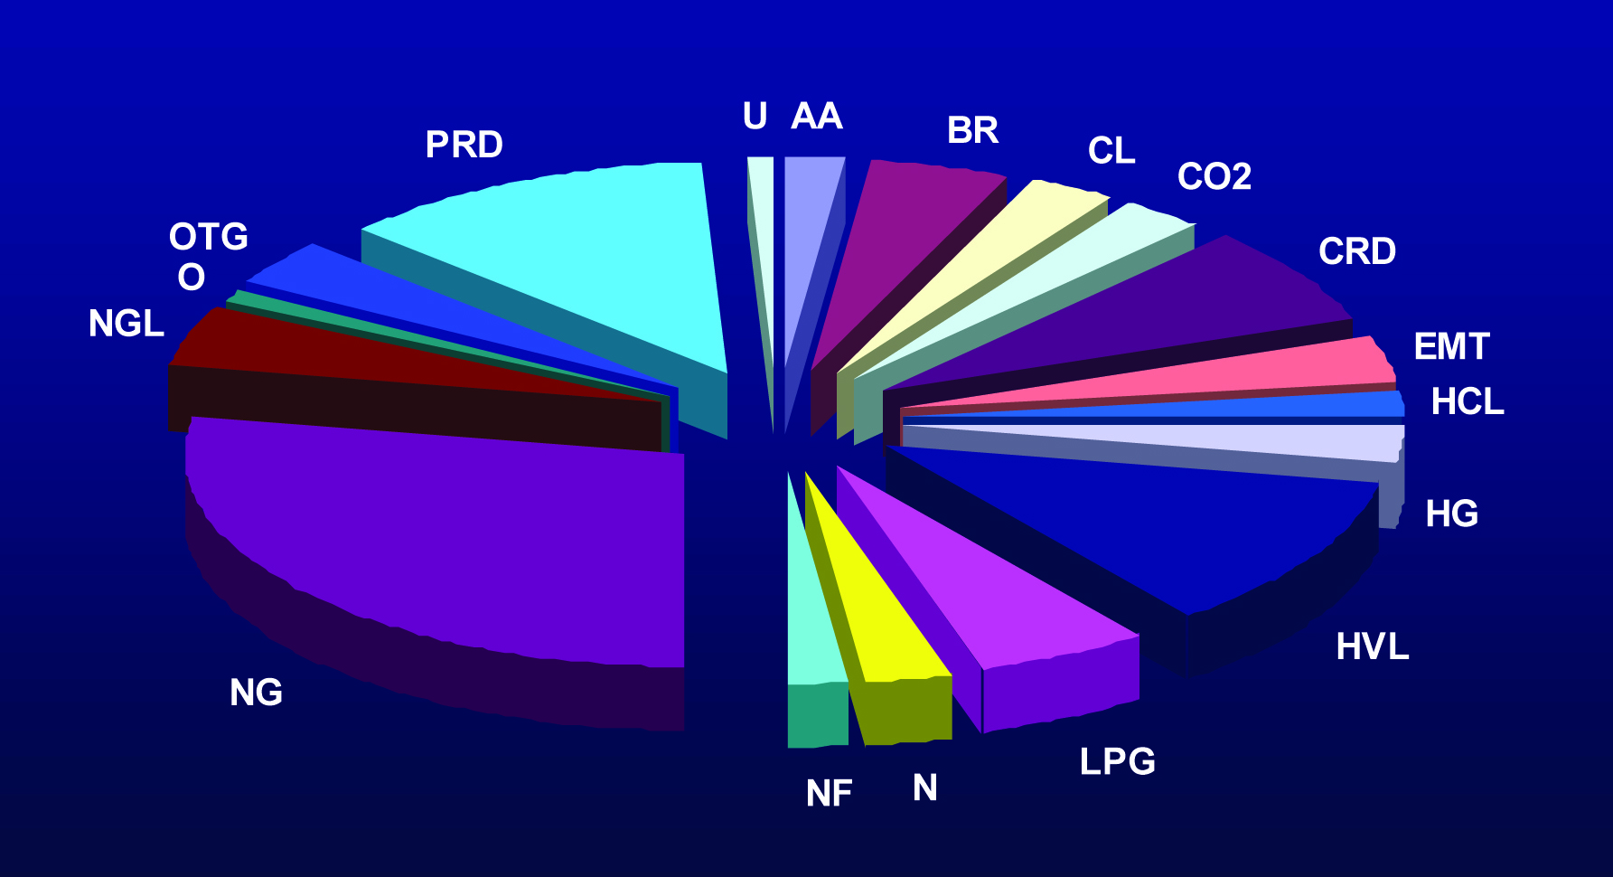
Percentage figures have been left off because of the vague commodities classification system. The abbreviations mostly witnessed are HVL (Highly Volatile Liquid), LPG (Liquid Petroleum Gas), and NGL (Natural Gas Liquids). For example, HVL is used to describe many commodities crude oil, propane or ethylene (in which LPG and even PRD are also used). Refer to table 6.1 for description of the abbreviations and the commodity descriptions (Cmdty_desc) field in the feature table for the description of the commodity within the pipelines.
Figure 2.4 Mileage by commodity

2.6 Pipeline Feature Development

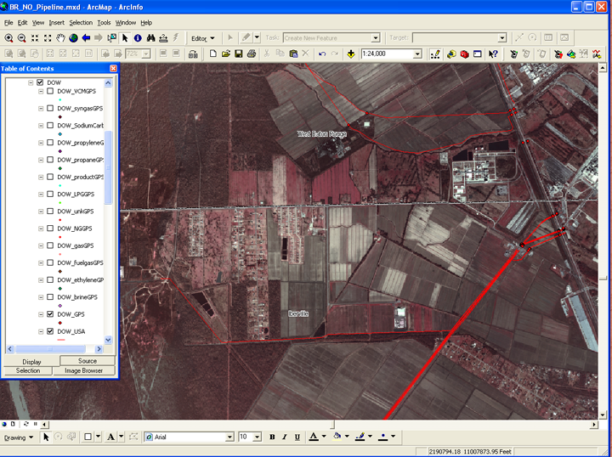
Pipeline features were prepared using heads up digitizing techniques in ArcMap 9.2. Using the edit function in ArcMap, polyline pipeline features were developed utilizing GPS point data, DOQQ imagery downloaded from the Louisiana State University CADGIS Lab Atlas website (http://atlas.lsu.edu/rasterdown.htm) and hard copy map data. The combination of the 1 meter resolution of the DOQQs, GPS point data, and reliable third party and operator pipeline maps enabled the heads up digitization of pipeline features in this project (Figure 2.5). Pipeline data were not created by the direct digitization of maps or diagrams in this project. Aerial image interpretation techniques were integral to this method of mapping. “Scars” of pipeline ROWs are clearly visible on the DOQQs. GPS data would allow for refined spatial placement of the pipeline features within the ROWs. Some of these new data are an improvement upon other digital data developed by pipeline operators or their representatives. Field research with GPS is very important for accurate pipeline mapping.
Figure 2.5 Pipeline feature development.
Group layers within ArcMap (ArcGIS 9.1, ESRI Inc., Redlands, CA) were created for each operator. Other layers were populated with requisite aerial imagery, GPS point data, existing digital pipeline data, road data, and other helpful themes from the LAGIS CD. Pipeline features were created utilizing heads-up digitizing techniques in ArcMap. Referencing NPMS data, the DTC Atlas, and other hard copy data, feature attributes were carefully digitized into the pipeline GIS following visible physical attributes on the imagery. Collected GPS point data were also used for verification of existing pipeline data, hard copy or digital and to spatially adjust digitized lines.
Great effort was taken to map pipelines as continuous linear features, as opposed to many line segments, as with some pipeline operator data. Pipeline features were mapped up to facilities such as pumping stations, compressor stations, and/or petrochemical plants. “In plant” pipelines were not mapped in this project. These include the overhead lines that go from plants to Mississippi River docks. However, pipelines within plant properties were mapped in the large ROWs along railroads and powerlines. This was done mostly for continuity. Valve stations are not included in this effort because of the lack of data on them and their inaccessibility. Future efforts in pipeline mapping can include the addition of interconnections, compressor stations, and valves. However, it is important to note here that no individual, except those authorized, should attempt to adjust any pipeline valves.
Attribute tables were developed and populated after the digitizing efforts were complete. These tables are modeled after the NPMS database design template. Attribute tables are created with the same field characteristics and definitions for pipeline data consistently throughout the pipeline mapping projects (Table 6.1).
There were, however, some discrepancies between reference data. The most common differences were for pipeline diameter and commodity transported (other than natural gas). Primary data sources included those of the NPMS data or operator submitted digital data. These data were developed and submitted by the pipeline operators or their representatives (contracted GIS developers). If no data were submitted to the NPMS, then research into hard copy maps submitted to LGS would show direction, commodity, and diameter of pipelines. However, some pipeline operators have not submitted data of any sort to NPMS or LGS. These features and attributes for these pipelines were determined by investigations into third party maps, mostly the DTC Industrial Atlas (Design Techniques Corporation, Houston, TX).
As previously mentioned, there has been 6,202 miles of pipeline features developed or spatially adjusted. Geographic relationships between pipelines features are important. The “spaghetti effect” of lines overlapping lines is being reduced if not eliminated as much as possible. However, there are areas in which pipelines are laid upon another. This is most evident in Scottlandville, in north Baton Rouge. The pipeline ROWs on either side on the railroad tracks are congested with pipelines. Typically, operators keep out of each others ROWs, but in some areas this is not possible. These areas are very difficult to map with great precision.

3.0 Industry

3.1 Pipeline Operators

There are some 67 pipeline operators observed within the study area. Some of the listed operators are subsidiaries of larger corporations, while parts of some pipeline systems have bee sold to other operating companies. The dynamics of the oil and gas industry can cause difficulties in development of a digital pipeline GIS. Corporate mergers, divestures and the myriad of legal restructuring is an obstacle to the identification of pipeline systems and/or segments. This is also evident in refining and gas processing industries. A primary task of the project is to acquire emergency contact telephone numbers that are labeled on warning signs that are located adjacent or on top of buried pipelines (Table 6.2). Although some pipeline operators have become part of larger corporations, their emergency contact numbers have not changed, some, on the other hand, have. The pipeline operators have been identified within the study area through intensive GPS data collection, internet searches, industrial handbooks and maps. Field data collection also documented commodities and emergency contact telephone numbers labeled on their respective warning signs (Table 6.3).

3.2 Industry and Pipelines

Industry along the Mississippi River began early in the 20th century. These plants were sited along the river mostly because of the transportation infrastructure. The river allowed for large, ocean going ships to navigate upriver to docks located adjacent to the plants. The ExxonMobil refinery in Baton Rouge was built by Standard Oil in 1909, Shell, at Norco, as the New Orleans Refining Company in 1916, and Mobil Refinery, as the Chalmette Petroleum Company, in 1915 to name a few. Once established, these large petroleum refineries enabled smaller industries to develop. The petroleum feedstock’s attracted numerous capital investments. Naturally, the pipeline infrastructure developed soon after the refineries to transport raw material (petroleum/natural gas) and feedstock (light ends or olefins) between refineries and other industry. Typically, refineries are unique in that each is designed for a certain type of crude oil. Also, each refinery produces a suite of organic chemicals that are used as feedstock for use either within the plant or piped off site for use in other plants. Early pipelines include crude and natural gas from the Midwest and Monroe Oil and Gas Field that were pipelined to the Standard Oil refinery in Baton Rouge. Included in the project are data (in the form of shapefile) showing the location, activities, and contacts of the industries in and directly adjacent to the study area.
A brief discussion of some of the industries and their relationship with the pipeline infrastructure follows. This list covers many of the larger plants and not smaller industrial sites or may not include plants that have shut down. It also contains pipeline operators, midstream as well as upstream and constituent industries.
Air Liquide supplies oxygen, nitrogen, hydrogen and many other gases and services to many industries (oil refining, chemical production, paper milling, and aerospace to name a few). The air separation units serve nitrogen and oxygen to DOW, OxyChem, Placid, ExxonMobil, Copolymer, Ashland Chemical, and others. The air separation plants are an integral part of a symbiotic network of organic chemical production facilities. Most of these air distillation facilities are located either adjacent to or within the larger chemical complexes.
Air Products: Also produces a number of gases and chemical intermediates that are used in organic chemical production, chiefly refinery hydrogen, through natural gas liquefaction. Advanced alkylamines, emulsifiers, surfactants are also produced. Air Products has recently, 2004, constructed a 110 million-scfd hydrogen plant to supply Motiva's Convent and Marathon Ashland's Garyville, Louisiana refineries and provide additional hydrogen to their Mississippi River corridor pipeline.
Albemarle Corporation: Alkenyl succinic anhydride production for ExxonMobil refinery.
Ampro Chemical (Triad Nitrogen): Ampro was a major producer of nitrogenous fertilizers. In 2003, the plant was idled indefinitely. Both Triad and AMPRO purchased natural gas from several pipelines at market price on short-term contracts.
Apex Oil Company: Located in Mt. Airy and Port Allen, Louisiana, roughly mile 145 and 230, respectively, adjacent to the Mississippi River. These Apex locations are small scale fuels terminals.
Ashland Chemical: see Shintech (purchase 2005)
Atofina: see Total Petrochemicals (purchase 2005)
BASF: Located adjacent to the Mississippi River, ethylene, oxygen and natural gas are transported through pipelines to this Geismar, Louisiana industrial complex for polyurethane, antifreeze, and many other compounds production.
BASF Catalysts: The port Allen Works produces alumina.
Borden Chemical: Borden Chemical is a leading supplier of high-performance resins, adhesives, coatings, and basic chemicals to a broad range of industries. This facility was due to be closed in 2002.
BOC Gases: The Gonzales plant produces gas and liquid argon, oxygen, and nitrogen.
BP Lubricants, Casrol: This Port Allen plant produces lubricating oils.
Calpine: Located off Louisiana highway 30, this electrical cogeneration facility began operations in 2002. Natural gas is the fuel for the turbines and is supplied via pipeline.
Capline Terminal: Locate in St. James Parish; this petroleum storage/distribution hub is operated by Shell Oil Company. This pipeline system serves crude oil to refineries in the Midwest, including the Williams refinery in Memphis, TN.
Cargill: An international provider of agricultural products. This facility in St. John the Baptist Parish ships grains worldwide.
CII Carbon (Calciner Industries): In the late 1980’s, CII separated from Kaiser Aluminum and Chemicals. Calcined coke production for use in the metals industry.
CF Industries: A large manufacturer and distributor of nitrogen and phosphate fertilizer products in North America. The Donaldsonville facility is unique in its ability to produce three major nitrogen fertilizers: solutions of ammonia, urea and nitrogen. Donaldsonville has on-site storage capacity for a full range of fertilizer products.
Chalmette Refining: Aromatic petrochemicals, fuels, propane, and sulfur. Also a refined products terminal and wharf facility.
Chemtura Corporation: Agricultural chemicals as well as rubber processing chemicals and synthetic rubber are produced at the Grenta plant. The Taft plant produces Olefins and styrenics as well as vinyl additives.
ChevronPhillips Chemical Co.: ChevronPhillips has a strong presence in the petrochemical industry in Louisiana. Several facilities are located adjacent to the Mississippi River. Within the study area, however, there is one facility in St. James Parish, Louisiana. Styrene monomer production is the focus of this facility.
Ciba Specilaty Chemicals (now part of BASF, 1998): This Iberville Parish facility produces over twenty products that are used in ink and dye production.
Colonial Pipeline: Baton Rouge Junction and Tank Farm. This facility stores and transports petroleum products.
Clean Harbors: Baton Rouge and White Castle plants dispose of hazardous materials.
Crompton: In 1996, Crompton purchased the Uniroyal Chemicals plant in Geismar, LA. This facility produces specialty rubbers and plant growth regulators.
CrossTex Energy Services: The Riverside Fractionation Plant in Geismar processes NGL into butane, ethane, and natural gasoline.
CrossTex LIG Liquids: Natural gasoline processing plant.
Delta Petroleum Company: Lubricant and chemical blending as well as storage.
Deltech Corporation: Specialty chemicals production facility.
Department of Energy: Strategic Petroleum Reserve. The Bayou Choctaw facility is a salt dome that has artificial caverns created to store a capacity of 72 million barrels of petroleum. This facility is used to store crude and other products (mostly ethylene). Another underground storage facility is located near Sorrento, LA., that is not part of the SPR. Several petrochemical industries utilize this facility for the storage of highly volatile liquids.
DOW USA: Dow facilities in Louisiana manufacture more than 100 basic and specialty chemicals such as polyethylene. In Plaquemine, 23 production units manufacture more than 50 different basic and specialty chemical products. The output of this plant is shipped for further processing by other DOW units or other industry. Other locations for DOW in the study area are Hahnville and Norco, St. Charles Parish (formerly Union Carbide), Reserve, St. John the Baptist Parish (50/50 joint venture with DuPont, known as DuPont Dow Elastomers LLC). It is no surprise that roughly 15% of the GPS points were for this major industry with several different commodities being transported between the facilities.
DuPont: The two plants within the study area produce sulfuric acid and specialty chemicals and polymers. The Darrow, Louisiana site produces acids and the LaPlace site producing neoprene rubber and aromatic diamines.
DuPont-De Nemours: Sulfuric acid production.
DuPont Dow Elastomeres: Polymer production.
Entergy: Electric production utilizing mostly natural gas and oil, with some nuclear. There are several facilities adjacent to the Mississippi River that rely on pipelined natural gas and/or fuel oil for electrical energy production.
Enterprise Products: Geismar operations are involved in natural gas fractionation. Fractionated product transportation and storage is a large part of their operations. Many of their facilities are joint ventures with other large petrochemical corporations.
Ergon Inc.: Crude oil terminal in Baton Rouge and St. James.
ExxonMobil: Tank farm facility in West Baton Rouge Parish. Refinery, chemical, and plastics plant located in East Baton Rouge Parish. Natural gasoline processing at the West Baton Rouge gas plant.
ExxonnMobil Lubricants: The Port Allen, LA facility began operations in 1990 with lubricants blending and packaging.
Ferro Corporation: The Baton Rouge plant produces organic and inorganic chemicals.
Formosa Plastics Corporation: Chemical intermediary production (caustic soda, chlorine, PVC, VCM, ethylene dichloride, sodium hydroxide, and suspension resin.
Geon Company: Occidental Petroleum Corporation signed a nonbinding letter of intent
with The Geon Company to combine the polyvinyl chloride (PVC) businesses of the two companies in a joint venture. Originally constructed by DOW, the powder compounding products joint venture, 90 percent owned by Geon and 10 percent by Occidental, will be formed involving an OxyChem plant being built in Pasadena, Texas, and Geon plants in Conroe, Texas, and Plaquemine, Louisiana.
Geismar Vinyls Company: Vinyl chloride monomers (VCM) production.
Georgia Gulf Chemicals & Vinyls: Georgia Gulf is a leading North American manufacturer and international marketer of two integrated chemical product lines, chlorovinyls and aromatics. The operations in Plaquemine include the production of chlorine, caustic soda, VCM, vinyl resins, phenol and acetone. Chlorine and its co-product caustic soda are also produced at this facility in the chlor-alkali facility by electrolysis of salt brine.
Georgia Pacific: Paper and pulp operations closed 2007.
Gramercy Alumina: Production of alumina, calcined petroleum coke, caustic soda, chlorine, and flourochemicals.
Harcros Chemicals: Specialty chemicals, emulsifiers, and surfactants.
Hexion Specialty Chemicals: Formaldehyde and urea production.
Hilcorp Energy: Comite Gas Plant processes natural gasoline. (was Duke)
Honeywell (Baton Rouge and Geismar): Large scale production of hydrofluoric and muriatic acid. Calcium chloride is also produced at the Baton Rouge plant as well as alternative refrigerants.
INEOS Flour Americas: This St. Gabreil plant produces alternative fluorocarbons and pesticides.
Innophos Inc.: This Geismar facility (formerly Rhodia) produces phosphate salts and food grade phosphoric acid.
Intercontinental Terminals Company: Refined petroleum products terminal located in Port Allen.
International Matex Tank Terminal: Storage terminal for non-flammable petroleum products and a range of natural oil products.
John W. Stone Oil Dist.: Refined petroleum products terminal.
Kaiser Aluminum and Specialty Chemical Corp.: This plant, along with several adjacent plants, was involved in alumina production. Kaiser filed for Chapter 11 bankruptcy.
Kinder Morgan Bulk Terminals: Baton Rouge has liquid and coke dock facilities. Chalmette is a coke terminal and dock facility. Harvey stores animal fats other natural oils as well as chemicals storage. The Gramercy and Geismar facilities are bulk terminals.
Kinder Morgan Liquids Terminal: Railroad and terminal facility.
Kinder Morgan Seven Oaks: This Westwego facility is a refined products terminal.
KOCH Industries: Petroleum storage facility in St. James Parish.
Lion Copolymer: Established in Baton Rouge, the Copolymer Corporation was a pioneer in the science of synthetic rubber production. In 1989, Copoly became a subsidiary of DSM, an international group of industrial companies. This facility produces styrene-butadiene rubber. The Geismar complex produces polymers and rubber chemicals.
LOCAP Terminal: Petroleum storage facility in St. James Parish. The facility interconnects Shell (Capline) and LOOP. LOCAP is operated by LOOP and has a capacity in excess of 1 million b/d.
Louis Dreyfus Energy Services: The Chalmette, Geismar, and Sorrento facilities extract and/or fractionate natural gas liquids.
Marathon Petroleum: Ashland’s crude oil refining, marketing and transportation operations (downstream activities) are operated by Marathon Ashland Petroleum LLC (MAP) in which Marathon owns 100 percent as of June 30, 2005. MAP ranks as the fifth-largest petroleum refiner in the United States and is a consistent leader in the downstream organic chemical industry. Marathon owns, operates, leases or has an ownership interest in approximately 8,400 miles of pipeline including interests in Capline, which transports crude oil from St. James, LA, the Louisiana Offshore Oil Port (LOOP) and LOCAP systems to Patoka, IL. The Zarchary Station serves as a refined products terminal.
Monsanto: Located around river mile 120, this large industrial facility produces herbicides and specialty products such as acetaminophen.
Mosaic Phosphates Company: Leading manufacturer of high quality fertilizer and animal nutrients. The two plants located between mile 130 and 167 utilize natural gas and ammonia for the production of product.
Motiva Enterprises: A joint venture between Shell and Saudi Aramco, Motiva has two large scale refineries within the study area. A high conversion fuels refinery is located in Convent, LA. This refinery utilizes imported crude oil while the Norco facility refines mostly Gulf of Mexico crude through the LOOP system. Motiva also has operations at the Sorrento Storage in Ascension Parish.
Murphy Oil USA: The Mereaux refinery produces diesel, gasoline, kerosene, propane gas, and sulfur.
Nalco Company: Inorganic industrial chemicals are produces at the Garyville plant, while melamine resin, and low solids acrylamides are produced at the Port Allen plant.
Ormet Primary Aluminum Corp.: Burnside bulk marine terminal.
OxyChem Corp: Occidental Chemical Corporation (OxyChem) is a leading North American manufacturer of basic chemicals, vinyls and performance chemicals. Three plants within the study area produce products ranging from potassium hydroxide, chlorinated isocyanurate products and resorcinol; they also produce mercaptan odorizing agents and sodium silicates. In 2004, Oxy purchased Vulcan Chemicals located in Geismar, LA. OxyChem also operates a cogeneration unit for the Taft plant.
PCS Nitrogen Fertilizer: The Geismar complex produces fertilizers.
Petroleum Fuel & Terminal Company: The Mt. Airy terminal produces asphaltic mixtures as well as gas oil, LVGO, and pitch nairn.
PetroLogistics Olefins: Cavern storage for ethylene (mostly) at the Bayou Choctaw salt dome in Iberville Parish.
Pinnacle Polymers: This polypropylene plastics plant utilizes propylene pipelined in from Marathon to produce some 800 million tons of products per year.
Pioneer Chlor-Alkali Company: This plant, located near St. Gabriel, LA, produces chlorine for nearby industries. Hydrogen is also produced and pipelined to adjacent plants.
Pipeline Technology: Operation center for pipeline activities.
Placid Refining: This small refinery is located in Port Allen across the river from the giant ExxonMobil refinery. This complex produces transportation fuels and has been in operation since 1972.
Plains Marketing: Storage facility and truck terminal in St. Gabreil. (formerly Scurlock).
Plantation Pipeline: Terminal and tank farm in Baton Rouge.
PolyOne: PolyOne is one of the world's largest polymer services company, providing customers with a single source for polymer, colorant, and additive products. The facility in Plaquemine, Louisiana, focuses on vinyl compounds.
PotashCorp (PCS Nitrogen). This Geismar, Louisiana, facility produces urea, ammonium nitrate and phosphate products for fertilizer production. They also produce nitric acid here.
Praxair: Many air separation facilities are located within the study area. One company is Praxair. There are facilities in Plaquemines and Hahnville, LA that separate oxygen, argon and nitrogen for industial uses. The Geismar, LA facility produces synthesis gas, hydrogen and carbon monoxide.
Reagent Chemical: Ammonium fluoride production and distribution of HCl.
Rhodia: Specialty Chemical Corporation located worldwide but with a plant in Baton Rouge and with the acquisition of LaRoche Industries (ammonia) a plant in Mt. Airy. Products produced include liquid sulfur dioxide, oleum, sodium sulfite/bisulfite, sulfuric acid (piped to Exxon), and vanillin.
Rubicon Chemicals: This joint venture between ICI and Uniroyal utilizes several petrochemical commodities in their specialty chemicals production.
Shell Chemical: This olefins derivatives complex located in Geismar is one of the world’s largest producers of linear primary alcohols. The downstream chemicals plant in Norco changed operations under a new name of Hexion Chemical. This plant produces a variety of polymers, resins and solvents. The St. Rose refinery produces distillates, gas oil, and naphtha.
Shintech: Located south of Plaquemine, Louisiana, a new Shintech facility will manufacture chlorine, caustic soda, and vinyl chloride monomer. This plant will augment their existing PVC plant in Addis, Louisiana.
Sid Richardson: Located in Addis, Louisiana, Sid Richardson is involved in rubber grade carbon black (furnace black) production.
Syngenta: Located adjacent to the Mississippi River, this St. Gabriel, LA, plant produces agricultural specialty chemicals. This plant uses or produces several toxic substances in the production of complex organic chemicals.
Sunshine Oil Storage: Petroleum storage in St. James Parish, Louisiana.
Tomah Products: Purchased from Shell in 1999, this Reserve, LA facility produces alcohol ethoxylates.
Total Petrochemicals: Located around river mile 188, this facility produces styrene monomers and polystyrene resin pellets.
Terra Industries (formerly Triad): Ammonia and urea are produced at this facility located next to CF Industries in Donaldsonville,LA.
Union Carbide: see DOW Chemical (this plant co-venture with DOW)
U.S. Filter Siemens: (AKA International refining) small scale refinery.
Valero Energy: Originally the Good Hope Refinery located in Norco, LA, this medium scale refinery uses roughly 200,000 barrels of oil per day.
Williams Olefins: A 50-mile pipeline network distributes ethylene from this Geismar facility to customers at other petrochemical facilities. However, the pipelines are labeled as Petrologistics.
Many industries are located within the study area and some may have been overlooked. The acquisitions and mergers are difficult to follow within the petrochemical industry as well as the pipeline industry. Although this project is to map pipelines, the relationship between the commodities transported by pipelines and industry within the study area gives an overall view on the importance of pipelines.

4.0 Conclusions

The compilation and spatial analysis of digital pipeline data for the state of Louisiana is a complex process that will take years to accomplish. The quantity and quality of data sources and the unique geographic parameters of each inhibit the rapid development of a full scale pipeline GIS for the state. Assessment of digital data, field investigations and the development of undocumented data are important to statewide implementation of the Louisiana Pipeline Inventory GIS (LaPIGIS). The most prominent problem with existing digital data is with spatial accuracy. Much of the digital data, digitized by the LGS or developed by the operators, was incorporated into the GIS and displayed numerous problems associated with spatial accuracy as well as the lack of emergency contact information. These issues were addressed by developing pipeline features utilizing GPS technology for spatial control and thorough documentation of data collected. The GPS point data were also used to verify pipeline operator name, the commodities transported, and pipeline incident emergency contact. Corporate mergers and acquisitions can be a problem when developing these data. As long as emergency contacts remain the same, these restructurings should not affect emergency response.
The data developed through this and future pipeline mapping projects will eventually provide a comprehensive pipeline inventory GIS for the state of Louisiana. As more operators develop and submit pipeline data and as the LGS and cooperative partners develop pipeline data, we will eventually have a comprehensive pipeline GIS for the state. However, no plans exist for the maintenance and update of these critical data. With the constant corporate restructuring and economic growth, these data will need updating on a regular basis.
The use of GPS technology is very useful in pipeline mapping. Eventually, with this and other pipeline mapping efforts sponsored by OSRADP and other agencies/programs, the puzzle of pipelines in Louisiana will be put together.

5.0 References

BRAUD, D., H. PEELE, B. ALETI, E. OZDENEROL, F. JONES, R. CUNNINGHAM, R. PAULSELL, J. SNEAD, D. GISCLAIR, D. DAVIS, 2000, Louisiana GIS-CD: A Digital Map of the State. Louisiana Oil Spill Coordinator’s Office. ArcView and Geomedia GIS on CD-ROM

BRAUD, D., R. CUNNINGHAM, F. JONES, J. KENT, H. PEELE, L. POND, D.SA, D. DAVIS, D. GISCLAIR, 2005, Louisiana GIS: May 2005 Supplemental DVD. Louisiana Oil Spill Coordinator’s Office.

DESIGN TECHNICS CORPORATION, 1992. Louisiana Parish Pipeline and Industrial Atlas. DTC, Inc., Houston, TX.

DESIGN TECHNICS CORPORATION, 2007. Texas & Louisiana Gulf Coast Industrial Handbook. DTC, Inc., Houston, TX.

Paulsell, R.L. 2002. Research and Development of a Geographical Information System of Petrochemical Transmission Pipelines in East Baton Rouge Parish, Louisiana: Louisiana State University, Louisiana Geological Survey. Louisiana Applied Oil Spill Research and Development Program, OSRADP Technical Report Series.

Paulsell, R.L. 2004. Research and Development of a Geographical Information System of Petrochemical Transmission Pipelines in the New Orleans Vicinity, Louisiana: Louisiana State University, Louisiana Geological Survey. Louisiana Applied Oil Spill Research and Development Program, OSRADP Technical Report Series.

LOUISIANA GEOLGICAL SURVEY, 2002. Selected Louisiana Oil and Gas Pipelines. Louisiana Geological Survey, Baton Rouge, LA. Unpublished ArcView GIS shape files and associated hard copy map submissions from pipeline operators.

NATIONAL PIPELINE MAPPING SYSTEM. Louisiana Pipelines. US Dept. of Transportation, Office of Pipeline Safety, Washington, DC. Unpublished ArcGIS shape files.

NATIONAL PIPELINE MAPPING SYSTEM, PHMSA fact sheets, http://primis.phmsa.dot.gov/comm/FactSheets

Midwest Publishing Company PC Directory. Digital Petroleum Industry Directory.

R.W.PETERSON, 2000. Homesite Company, “Giants on the River, A Story of Chemistry and the Industrial Development on the Lower Mississippi River Corridor.”

R.W.PETERSON, 2000. Homesite Company, “Lower Mississippi River 2002-2003 Directory of Petrochemical Industries.”

U.S. GEOLOGICAL SURVEY, 1978-1993. 7.5-Minute Topographic Quadrangles, US Geological Survey, Reston, VA, various quadrangles, 1:24,000

Various Pipeline Operator and industry web sites.

2004 Emergency Response Guidebook (ERG2004) was developed jointly by Transport
Canada (TC), the U.S. Department of Transportation (DOT), the Secretariat of Transport and
Communications of Mexico (SCT) and with the collaboration of CIQUIME (Centro de Información Química para Emergencias) of Argentina, for use by fire fighters, police, and other emergency services personnel who may be the first to arrive at the scene of a transportation incident involving dangerous goods. DOT/RSPA http://hazmat.dot.gov/gydebook.htm

Miesner, Thomas O., and Leffler, William L., “Oil & Gas Pipelines, in Nontechnical Language” Copyright 2006, PennWell Corporation, Tulsa, OK.

6.0 Appendices

Table 6.1 the following table lists pipeline operators found in the study area. Also listed are the associated emergency contact telephone numbers. These include observed gathering system operators where documented. This list will be revised next year to reflect all of the pipeline operators within the study area. This will include industry as well. A few industries are listed here, but this list is mostly operators of pipelines that extend over the expansive study area. Many of these industries have only pipelines that extend from the plant across the highway to loading docks on the Mississippi River.

Table 6.1 Database definitions for pipeline attributes developed for the Pipeline GIS.

C=charater,
R=real number
Oper_nm | C 40 | Name of pipeline operator
Sys_nm | C 40 | Pipeline system name, assigned by operator
Diameter | C 5 | Pipeline diameter (two decimal places if needed)
Commodity1 | C 3 | Abbreviation for primary commodity transported
Commodity2 | C 3 | Abbreviation for other commodity transported
Commodity3 | C 3 | Abbreviation for other commodity transported
Cmdty_desc | C 40 | Description of primary commodity transported
Status_cd | C 1 | Current pipeline status
Quality_cd | C 1 | Positional accuracy of features
Revis_date | C 8 | Date of feature creation or update (YYYYMMDD)
D_link | C 40 | for links to digital files
Emergency | C 12 | Emergency telephone contact (on warning signs)
Emergency2 | C 12 | Other emergency telephone contact
Meta_name | C 20 | Name of metadata file
Comments | C 40 | other information

Abbreviations for transported commodities: AA=Anhydrous Ammonia, BR=Brine, CL=Chlorine,CO2=Carbon Dioxide, CRD=Crude Oil, EMT= Empty, HCL= Hydrochloric acid, HG= Hydrogen, HVL=Highly Volatile Liquids, LPG=Liquefied Petroleum Gas, N= Nitrogen, NG=Natural Gas, NGL=Natural Gas Liquids, NF=Non flammable, O= Oxygen, OTG= Other gases, PRD=Products, U= Unknown
Current pipeline status: I=In Service, B=Abandoned, R=Retired, U=Unknown
Positional accuracy: E=Better than 50 feet, V=51" - 300", G=301' - 500', P=501 - 1000', U=Unknown
Table 6.2 Pipeline operator emergency contact telephone numbers.

Operator Name | Emergency Phn | Emergency Alt. | LA One Call
Acadian Gas Pipeline | 800-600-6240 |  | 800-600-6240
Air Liquide | 713-864-7764 |  | Not Listed
Air Products | 800-577-3341 |  | 225-473-4631
Ashland Chemical | 225-685-3400 |  | 225-685-3400
Atmos Energy | 800-654-6669 | 800-252-3323 | 504-458-7356
Bengal Pipeline (Shell) | 800-852-7614 |  | Not Listed
BOC Gases | 800-232-4726 |  | Not Listed
BP America Production | 800-252-3006 | 225-637-4942 | 903-297-4023
Bridgeline Holdings | 800-762-3404 | 504-464--0848 | Not Listed
Buckeye Gulf Coast Pipeline | 713-651-1464 |  | 713-651-1464
Chevron Pipeline | 318-232-7500 | 800-762-3404 | 800-762-3404
Clovelly Oil | 504-465-0574 |  | Not Listed
Collins Pipeline | 601-765-6593 |  | 601-765-6593
Colonial Pipeline | 800-926-2728 | 409-722-1664 | 409-722-1664
Columbia Gulf Transmission | 713-621-0101 | 866-485-3427 | 504-879-3301
Cora-Texas | 225-545-3679 |  | 225-545-3679
CrossTex Processing Services | 800-979-3391 |  | 214-953-9500
CrossTex-LIG | 318-445-4568 | 318-619-5704 | 318-619-5704
Cypress Gas | 800-600-6240 |  | 800-600-6240
Deltech | 225-775-0150 |  | Not Listed
Denbury Onshore | 888-651-7647 |  | 985-857-9215
Dixie Pipeline | 800-349-4377 |  | 225-654-4112
DOW USA | 800-223-4412 |  | 800-223-4412
Dynegy Midstream | 800-483-9568 |  | Not Listed
El Paso Field Services | 800-979-3391 | 800-895-2396 | Not Listed
Enbridge Pipeline | 800-650-8099 | 800-926-4352 | Not Listed
Entergy | 800-368-3749 | 504-374-4401 | 504-526-7110
Enterprise Products | 888-506-8528 | 225-675-5378 | 888-506-8528
EOTT Energy | 800-844-3593 |  | Not Listed
Evangeline Gas | 800-600-6240 |  | 800-600-6240
ExxonMobil Pipeline | 800-537-5200 | 713-656-1234 | 800-220-2701
Florida Gas Transmission | 800-238-5066 |  | 800-238-5066
Formosa Plastics | 225-356-3341 |  | Not Listed
Georgia Gulf Corporation | 800-259-0573 |  | Not Listed
Goldking | 713-658-8286 |  | Not Listed
Gulf South | 800-850-0051 |  | 800-850-0051
Henry Producing Co. | 337-233-6547 |  | Not Listed
Hexion | 504-783-7200 |  | 985-446-4525
Hilcorp Energy | 337-406-2828 | 337-739-0754 | 337-739-0754
Hill Transportation | Not Labeled |  | Not Listed
Iberville Parish Dist. | 225-687-5152 | 800-273-2484 | Not Listed
Kaneb Pipeline | 800-666-0180 | 800-272-3020 | 800-666-0180
Kinder Morgan | 888-844-5658 |  | Not Listed
KOCH Hydrocarbon | 800-666-9041 | 800-292-3146 | Not Listed
LaRoche | 504-869-6400 |  | Not Listed
LOCAP, Inc | 504-632-6969 |  | 504-632-6969
LOOP, Inc | Not Labeled |  | 504-632-1315
Louis Dreyfus Pipeline | 888-294-3940 |  | 225-677-9399
Louisiana Gas Service | 504-367-7000 | 800-654-6669 | Not Listed
Louisiana One Call | 800-272-3020 |  | Not Listed
Marathon Pipeline | 800-537-6644 |  | Not Listed
Moem Pipeline | 601-765-6593 |  | Not Listed
Motiva Enterprises (Norco) | 225-562-6266 | 504-728-7893 | 504-268-0704
National Energy Group | 800-733-9211 | 504-759-7971 | Not Listed
Olympic Pipeline | Not Labeled |  | Not Listed
OxyChem Corporation | 504-783-7200 |  | 504-783-7200
Panaco Inc | 877-367-3120 | 713-970-3100 | Not Listed
PB Energy Storage Services | 800-420-9818 | 409-839-4400 | 866-527-3133
PCS Nitrogen | 225-621-1500 |  | 225-621-1500
PetroLogistics Olefins | 225-387-0871 |  | 225-387-0871
Pioneer | 225-642-1800 |  | Not Listed
Pipeline Technology Group | 888-650-4443 |  | Not Listed
Placid Refinig | 225-387-0278 |  | Not Listed
Plains Pipeline | 800-708-5071 |  | Not Listed
Plantation Pipeline | 800-510-5678 |  | Not Listed
Praxair | 800-645-4633 |  | 225-343-1524
Rhodia | 225-356-7111 |  | Not Listed
Rock Island Oil Co | 225-356-4513 |  | Not Listed
Scurlock Oil (Plains American) | 713-739-4100 |  | Not Listed
Shell (La Capline) | 800-852-8144 |  | Not listed
Shell Pipeline | 800-852-7614 | 800-922-3459 | Not Listed
Southern Natural Gas | 800-252-5960 |  | Not Listed
Sport Pipeline | 318-221-4959 |  | Not Listed
St. James Utility | 225-562-2364 | 225-265-3156 | Not Listed
Tennessee Gas Pipeline | 800-231-2800 |  | 800-231-2800
Texaco Pipeline | 800-762-3404 | 800-922-3459 | 800-762-3404
Texas Brine | 504-369-6657 | 985-369-6657 | 504-369-6657
Texas Eastern Transmission | 800-231-7794 |  | 713-598-3150
Total Petrochemicals | 225-642-5454 |  | Not Listed
Tri States Pipeline | 888-506-8528 |  | Not Listed
Triad Nitrogen | 225-474-4641 |  | Not Listed
Union Carbide | 888-278-3413 | 888-278-3414 | 800-223-4412
Varibus Corp. | 409-839-4400 |  | 409-839-4400
Vernon E Falconer | 337-332-1726 |  | Not Listed
West Baton Rouge Parish Dist. | 225-343-9234 | 225-336-2406 | Not Listed
Williams Gas Pipeline (Transco) | 800-440-8475 | 713-626-3061 | Not Listed

Table 6.3 This table shows the petrochemical commodities labeled on pipeline warning signs.

Pipeline Operator | Commodities Transported
Acadian Gas Pipeline | Natural Gas
Air Liquide | Natural Gas, Nitrogen, Oxygen
Air Products | Hydrogen, Nitrogen
Ashland Chemical | Gas (type unspecified on signs)
Atmos Energy | Natural Gas
BOC Gases | Nitrogen
BP America Production | Natural Gas, Petroleum
Bridgeline Holdings | Natural Gas
Buckeye Gulf Coast | Petroleum Product (Butadiene)
Chevron Pipeline | Crude Oil, Petroleum Products (Ethylene, EP Mix)
Clovelly Oil | Natural Gas
Collins Pipeline | Petroleum Products (Gasoline)
Colonial Pipeline | Petroleum Products (retired line)
Columbia Gulf Transmission | Natural Gas
CrossTex Processing Services | Natural Gas Liquids, Highly Volatile Liquids
CrossTex-LIG | Natural Gas
Cypress Gas (Acadian) | Natural Gas
Deltech | Petroleum Products (Benzene, Styrene)
Denbury Onshore | Carbon Dioxide
Denbury Onshore | Carbon Dioxide
Dixie Pipeline | Petroleum Products (Propane)
DOW USA | Brine, Butane, Ethylene, Fuelgas, Gas (unspecified), Naptha, Natural Gas, LPG, Products, Propane, Propylene, Sodium Carbonate, Syngas, VCM
Dynegy Midstream | Idle (NGL)
El Paso Field Services | Crude Oil, Natural Gas
Enbridge Pipeline | Natural Gas, Petroleum Products (Propylene)
Entergy | Natural Gas
Enterprise Products Partners | Butane, Crude Oil, Natural Gas Liquids (Ethane, Propane, Propylene)
Evangeline Gas (Acadian) | Natural Gas
ExxonMobil Pipeline | Crude Oil, Petroleum Products, Liquid Petroleum Gas, (Butadiene, Butadiene, Butane, Butylene, EP Mix, Ethane, Ethylene, Isobutane, Propane, Propylene, Propylene Dilute, Raw Make)
Florida Gas Transmission | Natural Gas
Formosa Plastics | Brine
Georgia Gulf Corporation | Carbon Dioxide
Goldking/Panaco | Natural Gas
Gulf South Pipeline | Natural Gas
Hexion Specialty Chemicals | Chlorine, Hydrochloric Acid
Hilcorp Pipeline | Natural Gas
Hill Transportation | Natural Gas
Kaneb Pipeline | Anhydrous Ammonia
Kinder Morgan | Petroleum Products (Benzene, Natural Gas, Sodium Sulfide, Trichloroethylene)
KOCH Hydrocarbon | Crude Oil
LaRoche Industries | Brine
Louis Dreyfus Pipeline | Natural Gas Liquids
Louisiana Gas Development | Natural Gas
Louisiana Gas Service (Atmos Energy) | Natural Gas
Louisiana Offshore Oil Platform (LOOP) | Crude Oil
Marathon Pipeline | Crude Oil, Petroleum Product (Gasoline)
Moem Pipeline | Crude Oil
Motiva Enterprises | Petroleum Products, Liquid Petroleum Gas
National Energy Group | Crude Oil
Olympic Pipeline | Natural Gas (Abandoned?)
OxyChem Corporation | Chlorine, Natural Gas
PB Energy Corporation | Brine, Natural Gas
PCS Nitrogen Fertilizer | Anhydrous Hydrochloric Acid, Carbon Dioxide
PetroLogistics | Petroleum Products, Natural Gas Liquids (Ethane, Ethylene, Propylene)
Pioneer | Chlorine, Hydrogen
Pipeline Technology | Nitric Acid
Placid Refining | Petroleum Products (Fuels)
Plains American | Petroleum
Plantation Pipeline | Petroleum Products
Praxair | Hydrogen
Rhodia | Sulfuric Acid
Shell Pipeline | Crude Oil, Petroleum Products (Butadiene, Butane, Butylene, Ethylene, Hydrochloric Acid, Natural Gas, Octene, Process Gas, Propylene, Pyrolysis Gasoline)
Southern Natural Gas | Natural Gas
Sport Pipeline | Natural Gas
Tennessee Gas Pipeline | Natural Gas
Texaco Pipeline | Crude Oil, Highly Volatile Liquids, Liquid Petroleum Gas, Natural Gas Liquids
Texas Brine | Brine
Texas Eastern Transmission | Natural Gas
Tri States Pipeline | Natural Gas Liquids
Union Carbide Pipeline | Liquid Petroleum Gas (Ethylene, Ethane, Fuel Gas)
Williams Gas Pipeline (Transco) | Natural Gas

Table 6.4 Pipeline mileage by commodity

COMMODITY1 | miles
AA | 95.57
BR | 191.30
CL | 16.25
CO2 | 42.74
CRD | 440.77
EMT | 94.86
HCL | 2.09
HG | 151.60
HVL | 1436.03
LPG | 460.31
N | 110.36
NF | 29.09
NG | 2166.01
NGL | 161.60
O | 114.98
OTG | 94.13
PRD | 592.73
U | 1.99
 | 6202.41

Abbreviations for transported commodities: AA=Anhydrous Ammonia, BR=Brine, CL=Chlorine,CO2=Carbon Dioxide, CRD=Crude Oil, EMT= Empty, HCL= Hydrochloric acid, HG= Hydrogen, HVL=Highly Volatile Liquids, LPG=Liquefied Petroleum Gas, N= Nitrogen, NG=Natural Gas, NGL=Natural Gas Liquids, NF=Non flammable, O= Oxygen, OTG= Other gases, PRD=Products, U= Unknown

