Causal Argument Essay
English 2000 – Wingenbach

Rough Draft: March 15
Final Draft: March 29

For your second major essay of English 2000, you will write a causal argument. This type of essay is unique in that it works in two different ways. You can either: a) identify a particular phenomenon and discuss the resulting effects, or b) identify a particular phenomenon and discuss the underlying causes. In either case you will be examining the interaction between a specific issue or phenomenon and the placement and influence of this issue / phenomenon in a larger context. In other words, you can discuss a cause that leads to several effects, or an effect that has several causes. Regardless of which type of causation you choose, be sure to address the stakes of your analysis by correctly identifying the audience and producers for a given issue.

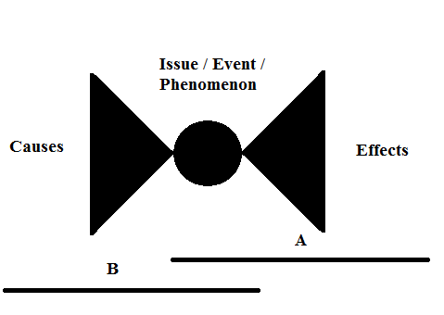

Assignment Objectives:
- Clearly identify the primary effect(s) an issue or phenomenon has had on a specific audience(s), or clearly identify the primary causes which have resulted in a specific issue / phenomenon.
- Be able to compile a thorough bibliography of relevant primary and secondary sources and incorporate each of those sources in your essay.
- Establish a consistent and manageable scope of investigation for the causes or effects of your chosen issue / phenomenon.
- Perform and present thorough research which aims to avoid overlooking major causes and effects of a given issue. Make a clear distinction between primary effects / causes and secondary ones.
Assignment Requirements:
- Formatting as prescribed by the class syllabus
- 1700 word minimum
- Correct citation of source article in analysis.
- A correctly formatted bibliography of at least six sources: at least four peer-reviewed and two primary sources.
Steps:
- Unless you are completely sick of the issue you have been working with, I encourage you to continue to keep the same one. There are several reasons for this. First, you have already researched this topic and may be able to reuse some of the sources you have already accrued. Second, even though you will need to do additional research, you should have a good idea about where to go for resources. If you do want to switch topics please set up a time to speak with me so we can find something that will be productive and appropriate.

- Some of you will need to narrow your topic to a more specific event, issue, or phenomenon. This is the difference between the Roe vs. Wade court decision and abortion as it has developed over the last forty years. Another example might be government funding for the BP oil spill clean-up in the gulf as opposed to a critique of government funded initiatives in the gulf region since Hurricane Katrina.

- Expand your bank of source material. Those of you who are staying with the same general topic should have some materials you can reincorporate into this assignment. This being said, you will be expanding your research in one of two directions depending on which version of the assignment you focus on. This time when you research you will be looking for articles and essay which expound either causes or effect of your issue.

- Develop a profile of the producers (b) and audience (a) of the issue you are researching. This will help you determine causes and effects later on. At this point it might be helpful to consult the CQ database we explored in class. Your profile of the producers and audience should be pretty detailed and specific. As before, saying that everyone is the audience of an issue won’t help you because it is too broad. Even if your issue affects a lot of people or was caused by a lot of different things you will need to make some distinctions. There will always be some people who have a greater stake in a given issue.

- Compare and Contrast the causes or effects of your issue as they pertain to different producers and audiences. Find out where the common areas of interest are. Likewise, find the areas of interest which are unique to certain groups. When the time comes, develop a thesis which makes a statement about what the primary cause(s) or effect(s) of the event in question are / were.

- Right. So what exactly is being argued? While we are not quite to a full-on argument of what is right or wrong, this assignment is completely built around argument. Specifically, you are taking a multiplicity of causes and effects and arguing which ones are the most important and significant.
As usual, a grading rubric will be posted in Moodle shortly.

