Title: Raising the Bar: Interpreting Data
Appropriate Grade Levels: 2-3
Activity Objective: To teach bar graph concepts while also expanding students’ understanding of careers that use graphing.
Materials Needed: The activity may be done as an art or snack time activity—or both!
-Construction Paper -Fruit loops (or any colorful candy) - Socks
-Masking tape -Legos (or any colorful toys) -Markers/Crayons
What are bar graphs? A bar graph is a kind of graph that is used to compare categories or groups of information. They are usually formed with rectangular bars, but can also be formed with real objects, pictures, or symbols.
https://www.math.net/bar-graph
Louisiana Grade Level Standard:
2.MD (Measurement and Data)
D. Represent and interpret data
10. Draw a picture graph and bar graph (with single-unit scale) to represent a data set with up to four categories. Solve simple put-together, take-apart, and compare problems using information presented in a bar graph.
Rationale: Bar graphs help children to understand information in a different way by organizing data. Bar graphs help children develop skills for recognizing patterns and trends on graphs and in the real world. Children also develop skills for comparing and contrasting that data while observing and building a bar graph. They are also able to develop sorting and categorizing skills.
Careers Related to Graphing:
Statisticians: design and manage experiments and surveys through analyzing collected data.
https://www.bls.gov/ooh/math/mathematicians-and-statisticians.htm

Atmospheric Scientists: study the weather and climate through collecting and analyzing data.
https://www.bls.gov/ooh/life-physical-and-social-science/atmospheric-scientists-including-meteorologists.htm

Medical Researchers: design and conduct studies to investigate and subsequently develop treatments for human illnesses.
https://www.bls.gov/ooh/life-physical-and-social-science/medical-scientists.htm

Actuaries: use mathematics and statistics to analyze financial costs of risks and uncertainty. These positions are essential to the insurance industry.
https://www.bls.gov/ooh/math/actuaries.htm

Coaches: instruct players in sports and will analyze data of players and strategies.
https://www.bls.gov/ooh/entertainment-and-sports/coaches-and-scouts.htm

Engineers: develop and maintain various systems and structures, whether that be buildings, chemicals, or software. They often use graphs to represent and understand complex data.
https://www.bls.gov/ooh/architecture-and-engineering/home.htm

Learn more: How can you and your child learn more about graphing at home for FREE?
- Use toys to make a pictograph. Sort toys by color, length, or type.
- Take a nature walk. Gather sticks, rocks, flowers, and leaves. When you return, create a graph to represent your findings.
  - Examples:
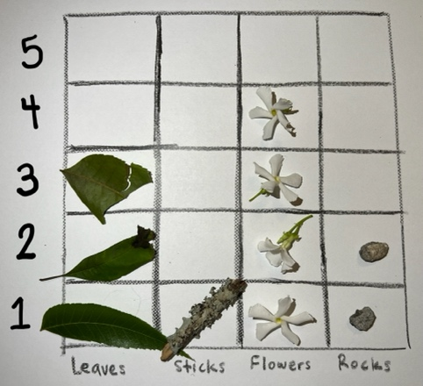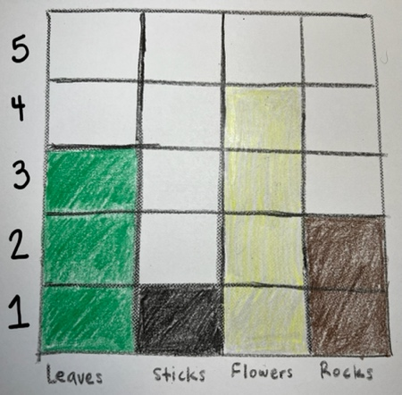
- Take a survey of your family friends! Ask them what their favorite things are (animals, foods, toys, etc.) and then graph them. For example, ask them what food they prefer like pizza, hamburgers, hot dogs, or tacos. Then graph those results.

Video:
https://www.youtube.com/watch?v=bo6kY3NHgSs

