How to Register for a Zoom workshop

- Go to lsu.zoom.us and click on Login

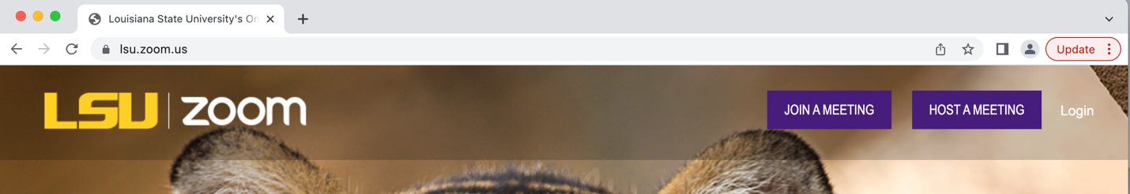

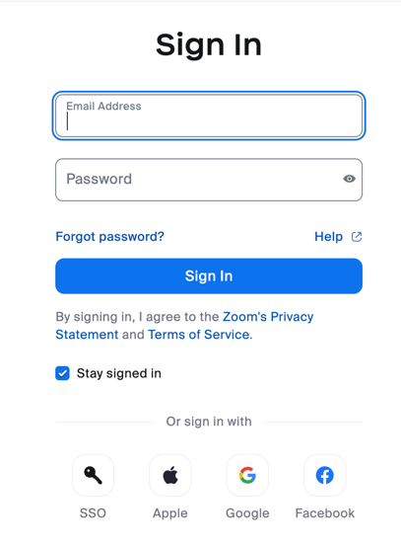
- Click on SSO

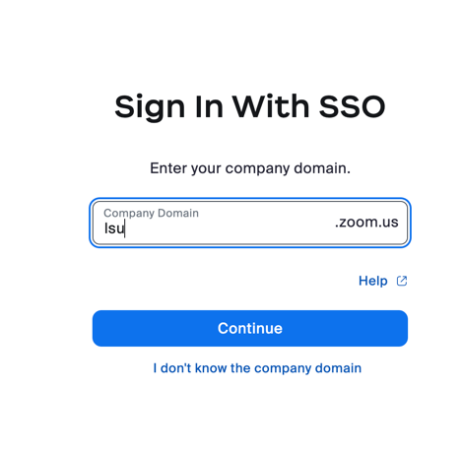
- Add “lsu” for your company domain.

- Enter your LSU email

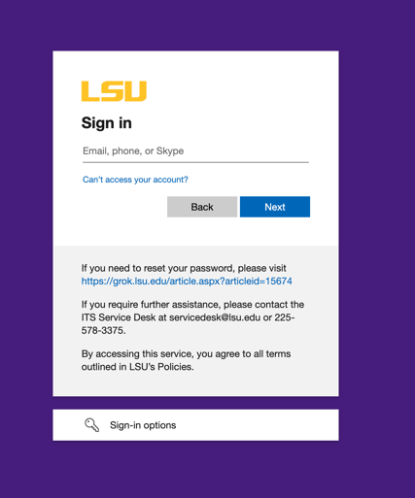

- Enter your MyLSU password

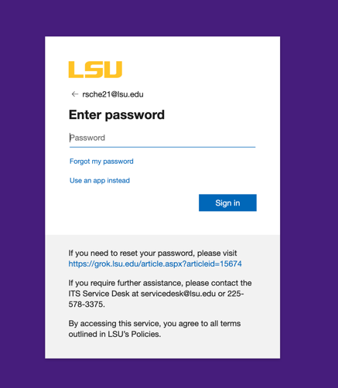

- Once you sign in this way, go back to the CAS webpage and click on the zoom link for the workshop you wish to attend. You should be able to fill out the information to register. Make sure to use your LSU email and password.

If you still get an error message, or if zoom automatically signs you in with your personal zoom, try these:
- Use a different browser
OR
- Go to zoom.us (maybe try this from a different browser as well)
- Then follow the directions above
OR
- Try signing out of zoom and signing in again using SSO (see above)
- Pictures to follow to show how to sign out of zoom.

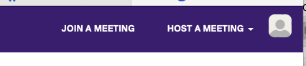
In the top right corner, look for the picture icon:

Click on it. The sign out will not show up until you hover over the space.
