Byzantine Icon Workshop
St. Therese
February 11 – 15, 2019
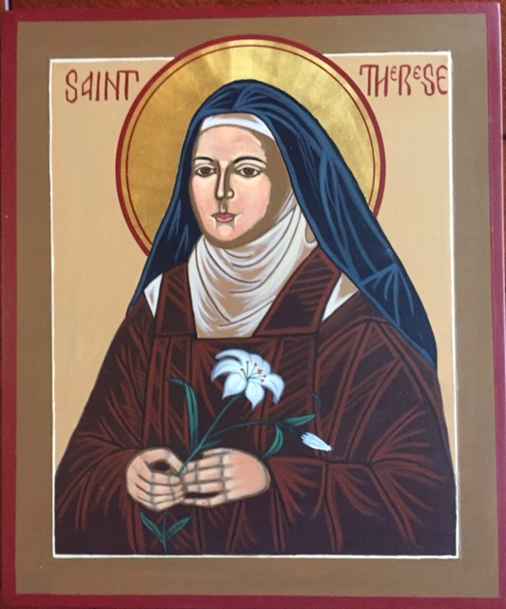
9 am – 4:30 pm

Friends of the LSU Botanic Gardens Burden are sponsoring a Byzantine Icon Workshop at the Burden Conference Center from February 11-15, 2019 from 9 am – 4:30 pm. A team of iconographers provides guided instructions that are paced to produce a finished icon of the St Therese.

The cost of the workshop is $350 and includes all materials and lunch for 5 days. A specially prepared board, gold leaf, all paints, brushes, and other supplies are provided. All proceeds benefit the Friends of the Gardens to further the implementation of the Botanic Gardens Master Plan.
Please return this form with the full payment of $350, or a $175 non-refundable deposit. The remaining $175 is due on or before January 7, 2019. If final payments are not received by January 7, the space will be offered to artists on the waiting list.
Checks should be made payable to Friends of the Gardens and mailed to:
Kitty Hessburg Wiemer
7636 Claret Ave.
Baton Rouge, LA 70809

Please contact Kitty Hessburg Weimer at 225-284-7440, or Diana Wells at 225-927-8646.

You may bring a 13-watt Ott desk lamp and/or a Sta-Wet palette for your own use.
I have a 13-watt Ott light desk lamp Yes____ No____. I have a Sta-Wet palette Yes ____ No _____. I plan to bring them to the workshop Yes ____ No _____.

Name _____________________________________________________________________________________________

Phone ________________________ email Address __________________________________

