Rhetoric of Propaganda
CMST 3168 Online Course

Professor: Stephanie Houston Grey
Office: Coates 224
Office Hours: Virtual
Contact: shgphd1@yahoo.com; 225-287-9022 (cell)

Course Description:
The 20th Century has been marked by the rise of nation states governed by either civil democracies or some type of autocratic bureaucracy. The maintenance of both systems has proven to be highly reliant upon propaganda as a means for welding diverse individuals into a common body. Only by participating in the collective fantasies of group identity can these individuals be transformed into a force for collective action. Thus the past century might be considered the age of propaganda. This class will focus on the evolving role of propaganda in societies that are increasingly marked by proliferations in technology. This class will explore the evolution of propaganda as we have moved from the age of electronic to digital media. One area of particular interest will be the ways that propaganda has become a field of contest where state authority often collides with disparate groups who seek to establish themselves as a legitimate challenge to this control. Indeed we may be entering a new age of propaganda wars as we see our political and cultural terrains increasingly fractured. In this class we will explore how best to manipulate the collective fantasy that we are a common people. Here are our specific goals:

- Trace the recent history of propaganda
- Explore the tactics and techniques of propaganda
- Understand the difference between state, corporate and resistance propaganda
- Develop an appreciation of the ethical issues raised by propaganda
- Develop critical thinking strategies that allow you to become a more sophisticated consumer of propaganda

Readings:

Timothy Borchers (2014). Persuasion in the Media Age: 3rd Edition, Boston: McGraw-Hill.

John Bowers, The Rhetoric of Agitation and Control, 3rd Edition. Long Grove: Waveland, 2010.

Assignments:

Essay Questions: You will be responsible for TEN of the FIFTEEN listed essay questions during the course of the semester. Essays should be about 250-350 words. Each essay is worth 75 points. 750 total points for this work and you must include your essay word count. You will be graded on the fundamentals of composition, organization, grammar, spelling, etc.

Final Exam: This comprehensive essay exam will be worth 250 points. Details to be provided as finals approach.

Grading:
1000-980: A+
979-929: A
928-900: A-
899-880: B+
879-829: B
828-800: B-
799-780: C+
779-729: C
728-700:C-
699-680:D+
679-629:D
628-600: D-
599 and below F

Policies:

For LSU’s policies on disability, explore this website:

http://students.lsu.edu/disability

For LSU’s policies on plagiarism, explore this website:

http://students.lsu.edu/saa/students/plagiarism

Late Work:

Work more that 3 days late will receive a one letter grade reduction, and another letter grade reduction for each additional three days. Please keep up with your work

Schedule:

Module One: Sept. 9
Module Two: Sept. 30
Module Three: Oct. 14
Module Four: Nov. 4
Module Five: Dec 2

Module One: Introduction
Read Borchers 1-3 Communication in General

- Propaganda is as old as human civilization. We can trace it through three distinct historical formats using differing types of media.
- From the classical to the modern period propaganda was based in a combination of written word and print.
- At the beginning of the 20th century we have the addition of electronic media such as radio and TV as a means for disseminating messages.
- Finally we are living in an age where internet and social media have further allowed social movements to coalesce around propaganda campaigns.
- What are some of the features of propaganda?
- It is persuasive.
- It is often part of a larger, coordinated effort by a group or nation.
- In can use any medium of influence.
- It is designed to influence large numbers of people.
- It can be launched by public or private entities.
- World War II and Propaganda
- We begin with World War Two because this marked a time frame when propaganda became both art and science.
- Governments sought to harness the media to manage national identity.
- It was the point at which propaganda reached a high level of sophistication.
- It saw a massive increase in money spend influencing public opinion.
- Text and Opening Essays
- In Borchers you will find a large number of theories of persuasion in the early chapters, including a reflection on ethics. We will be returning to these chapters throughout the semester.
- The texts you will examine will come from both Ally and Nazi film makers. The first two questions deal with Leni Riefenstahl’s documentary Triumph of the Will and Frank Capra’s Prelude to War. These were competing films.
- Triumph of the Will contains the Nazi message. Notice that you will see no ideology in the film. The only message is submission to Hitler and pride in country. Notice how Hitler descends from the clouds like a god in the beginning. He held many rallies at night because he felt the stronger will could subjugate the weaker will in the dark. While you might find parts of this film boring, remember that it was central to the German war machine that killed tens of millions of people and launched a genocide.
- America would respond with Frank Capra. Capra was selected because he was deemed to be a director that had his finger on the pulse of the average American (think Stephen Spielberg). The film was designed to prepare American GIs who were going to fight to resist enemy propaganda. It’s simple division of the world into light and dark is a classic of most nationalist propaganda. The first key is to keep the message simple.

Essay Question One: The following link will take you to one of the most iconic and infamous pieces of propaganda in history. Leni Riefenshahl’s Triumph of the Will depicts the rise and glorification of the Third Reich. It is set during a party festival. Drawing from at least three theories from Borchers explain both the power of the film and the power of the rallies depicted. One thing to pay attention to is the night rallies as opposed to those that take place during the day. Due 8/31

https://www.youtube.com/watch?v=GHs2coAzLJ8

Essay Question Two: The following link will take you to the American response to Triumph of the Will, Frank Capra’s Prelude to War. Drawing from at least three theories from Borchers describe how this film attempt to inoculate American troops from the effects of Reich propaganda. Make sure to include Kenneth Burke in your answer. Due 9/4

https://www.youtube.com/watch?v=Mm3GsSWKyso

Essay Question Three: This film asks you to reflect on cultural iconography during war time. Watch the following short Disney film featuring Donald Duck. Drawing from your reading explain why you think it is effective or ineffective. Due 9/11

https://www.youtube.com/watch?v=PL8FxDhsfhs

Module Two: Vision, Language and Ethos

Read Borchers 4, 6, 7, 9 Visual Language and ethos

- Source Ethos
- As the propaganda age as progressed consumers are more critical of these messages. Because of this sources must constantly monitor their credibility.
- Message source is important because it must connect with the audience. This means creating a sense of shared ethics or common enemy.
- Sources may seem credible because they have expertise, or rely upon dynamism—a concept that refers to innate charisma.
- Vision and Language
- Semiotic systems can be either visual or verbal. Signs can be a product of either words, photographic images or other displays. These symbols can change over time.
- Semiotic systems will often assign meanings to words or images that imply certain narratives. Take for example the raising of the flag over Mount Suribachi during the Battle of Iwo Jima:
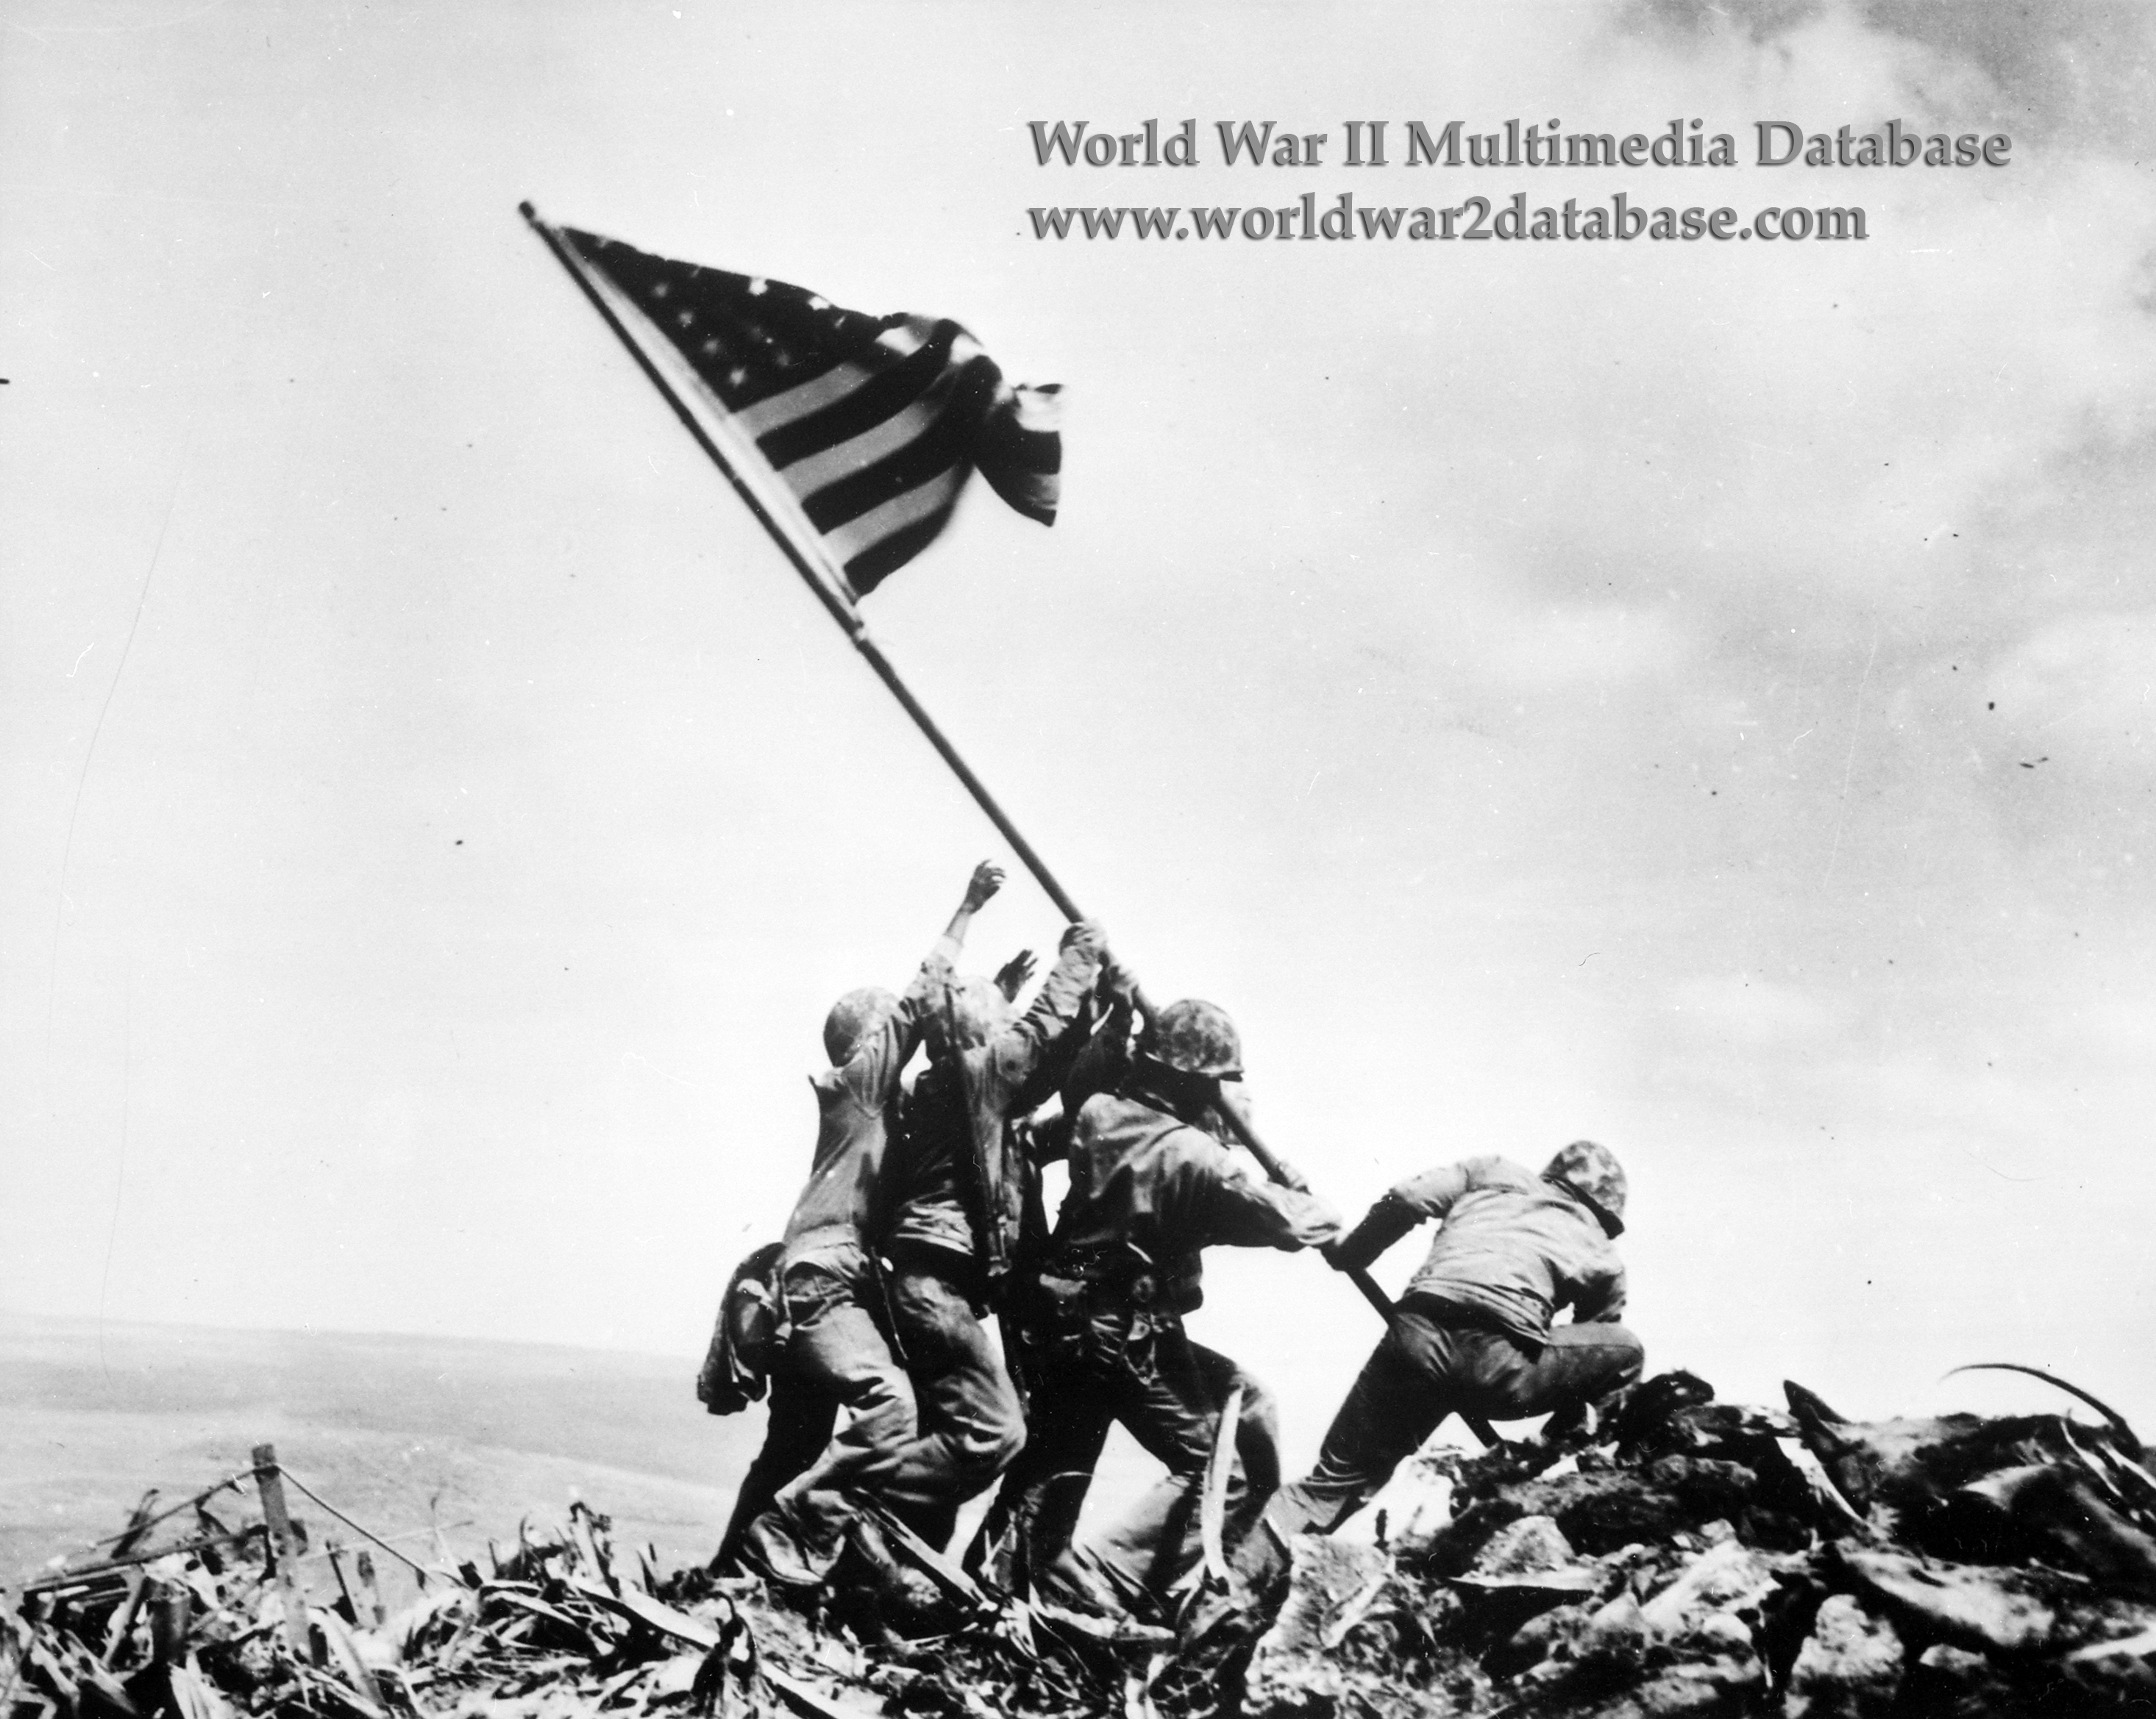
- This photograph is iconic and played a key role is war bond drives. It also has a key ideographic signifier to which it was linked. That word was “Victory.” Ideographs play a key role in propaganda campaigns because they are deeply entrenched in the cultural psyche.
- Examples for Exploration
- The first example you will explore is a famous speech by former President Bill Clinton. This speech came upon the heels of a media frenzy in the White House over the president’s affair with an intern. The question revolves around the use of key verbal signifiers to establish source credibility once it has been challenged.
- The second question will deal with the powerful narrative meanings behind the famous Mount Suribachi flag-raising. This photo was the most effective tool in the propaganda arsenal of World War II.
- The third question is a little more difficult. It takes place in the context of the Vietnam War. The photo is of Phan Thi Kim Phuc. She was the victim of a US Napalm attack during the war. The picture of her running from the scene of the bombing covered in burns was a blow to the US propaganda efforts during this war.

Essay Question Four: This is a speech given by former President Bill Clinton in an effort to restore his credibility in the wake of a political scandal. He uses a key ideographic signifier at least six times in this speech. Your hint is that it begins with the letter “P.” While he does apologize, notice how he also counter-attacks. Do you think this effort is successful in restoring his ethos? Why or why not? Use at least three concepts from the reading. Due 9/18

https://www.youtube.com/watch?v=UEmjwR0Rs20

Essay Question Five: Why is the Mount Suribachi photo such an effective propaganda tool? Can a visual photograph become an ideograph? Make sure to include at least three concepts from the reading in your answer. Due 9/25

Essay Question Six: The following link will take you to the Wiki Page on this event. It was covered from the ground after a US airstrike hit a Vietnamese village. The video is followed by civilians fleeing the napalm. Napalm is a liquid gel that burns at a very high temperature. She is eventually treated by an onlooking Marine. The girl in the center of the photograph with burns on her body was damaging to those who wanted to continue the war. Why is the photo so compelling? If you were in the position of defending the war at this time, how would you try to counter the effects of this image in your own propaganda. Make sure to sight at least three concepts from the readings in your answer. Due 10/2

https://en.wikipedia.org/wiki/Phan_Thi_Kim_Phuc

Module Three: Motive and Movement
Read Borchers 11-12

- Building Motive
- Part of being successful with any media campaign is learning who your target audience will be and how to influence them. One thing that is important to know is to focus upon ways to activate your audience.
- Audience attitudes are those shared traits and beliefs that bind a community together. You need to appeal to those shared motive structures.
- You must understand that a message that will work with one audience, will not work with another.
- Motive Building through Emotion
- Many media outlets rely heavily on stimulating an audience’s sense of rage.
- Related to rage is the sense of fear. When you frighten an audience, you can then make them mad that your target is not doing enough to stop whatever it is that is frightening them (i.e, illegal immigration, environmental depredation, etc.).
- You may pluck at their heartstrings through pathos or sadness.
- You can appeal to unconscious sexual drives.
- You can use humor.
- Disgust is a powerful tool when linked with moral outrage (i.e. conservatives who oppose same-sex marriage).
- Motive and Campaign
- You will be looking at examples of campaigns that use emotion as a means to drive social movements.
- Social movements are now integrated with new media and social media formats.
- Two of your essay questions will deal with the Chipotle brand which is a new type of corporate entity. It does not use broadcast media, but instead relies on social media and the internet. The appeal to a specific, environmental, food sovereignty movement in the US. They have also met with resistance.

Essay Question 7: The following presidential campaign aired during the 1964 presidential election. Remember that it was distributed during the Cold War. What emotion does it provoke? Why was it effective as propaganda? Would it work today? Why or why not? Remember to cite at least three idea from your reading. Due 10/9

https://www.youtube.com/watch?v=dDTBnsqxZ3k

Essay Question 8: Here is a viral video from Chipotle. Who are they targeting with this campaign? What emotions are they manipulating? Due 10/16

https://www.youtube.com/watch?v=lUtnas5ScSE

Essay Question 9: Here is an ad created by Chipotle’s opponents seeking to detach the corporation from the food sovereignty movement. Notice how it attacks Chipotle as manipulative. Do you think that the ad is successful? Do you think the Chipotle company is being unethical with their scarecrow campaign after watching this parody? Due 10/23

https://www.youtube.com/watch?v=y8R4dvZJ9Ck

Module Four: The Modern Era of Resistance
Read Bowers 1-6 through the sixties

- Agitation and Control
- One cannot appreciate the role of propaganda without first understanding the dynamics of agitation and control.
- In a democratic society defined by media, it is important to control the outlets of information for shaping public opinion.
- When the government or corporate entities are perceived to infringe of public rights, these wars will be waged in the media.
- Agitation and control is about using extreme methods to modify dominant messages and reshape the propaganda terrain.
- Non-Violent Agitation
- Agitation movements have a long tradition in American culture with moments of armed resistance tracing back to the Whiskey Rebellion. This, along with the early labor movements, were often violent and provoked crushing confrontations in which public opinion turned against those who instigated them.
- Beginning with the nonviolent practice of Gandhi these movements turned from violent revolutionary encounters into movements designed to shape public opinion and channel outrage.
- This was clearly demonstrated in the US with the Civil Rights Movement where protesters, dressed in Sunday clothes, would allow themselves to be confronted by police. This often meant being attacked and injured. The key was not to strike back. The image event that this generated would often create a public backlash against the institutions of control.
- Control
- By the time we enter the Vietnam Era protesters began to use more provocative tactics that might involve taunting police.
- It is important to note that the news media feed off of conflict. It is a fact that a peaceful protest will draw less attention than one that turns violent. The key in these situations is to shape the way that the violence will be perceived.
- If the protest movement can goad the power of control into confrontation, these will often turn public opinion against the state.

Essay Question 10: The following is a brief video on a Civil Rights protest in Alabama. It includes video footage and reflections from those who participated. What made this event so successful in turning public opinion? Cite at least three ideas from the readings. Due 10/30

https://www.youtube.com/watch?v=ggUt0gJh9U8

Essay Question 11: It is a video from the 1968 democratic convention. Anti-war sentiments were at their peak. Outside the convention the streets went into chaos and the police responded with overwhelming force. Do you think this hurt or helped the anti-war movement? Cite at least three ideas from the readings. Due 11/6

https://www.youtube.com/watch?v=7_9OJnRnZjU

Essay Question 12: The powers of control are never that far behind. This video is simply amazing. This is a protest drill from an anti-demonstration squad in Korea. It shows how state entities are now preparing to meet these types of protest. What does this video tell you about the state of agitation in the modern era? Has it become almost routine? Due 11/13

https://www.youtube.com/watch?v=uREJILOby-c

Module Five: A New Era of Propaganda

Read Bowers 7-9

- Entering the Digital Era
- Increasingly the sense of public is moving into the sphere of social media. These outlets differ from traditional broadcast media because users play a role in actively shaping a message.
- Social media are a double-edged sword for corporations. First they can disseminate a message even more broadly. However it is more difficult to control negative messages.
- This is the reason more restrictive governments often go to some lengths to limit internet search access to their citizens.
- Using Social Media as Propaganda
- Using social media means that one has to cut through the noise generated by so many other messages.
- Social media entails generating buzz around a particular idea. This means getting people to retweet or share these messages.
- The ideas or memes on these sites often involve ideas becoming viral.
- Social Media as Resistance?
- In some cases social media can be used to raise awareness.
- There is some question as to whether or not it is an effective sphere due to the individuals who troll—generating conflict for the sake of itself.
- If one looks at an organization such as ISIS (ISIL), much of its success is based around a very carefully crafted social media campaign designed to recruit individuals in other countries, persuading them to carry out attacks in those contexts.
- The question remains to be seen as to whether or not social media can generate real social change by sustaining a particular message.

Essay Question 13: Here is a campaign ad from 2008. Mike Gravel was running as a person outside the political beltway on a program of government and corporate reform. This is one of his campaign ads launched as a Youtube video. He is simply trying to cut through the noise at get people to see him. Is it successful? Cite at least three ideas from the book. Due 11/20

https://www.youtube.com/watch?v=0rZdAB4V_j8

Essay Question 14: Select some anti and pro Louisiana environmental discourse (public commentary). Show me what you think is true and what you think is propaganda. Why? Due 11/27

Essay Question 15: Many of you have grown up in an era where you have never known a time without war. As we have seen, the propaganda wars during the last half of the twentieth century over the US involvement in overseas conflicts grew increasingly intense. Yet the anti-war movement of the 21st Century has had considerably less visibility and traction. What is the difference? Is government propaganda just more effective now? Can you account for this? Due 12/2

Final exam date: Due 12/9

