Louisiana State University / Université des Antilles : Échange 2018
La Martinique et la Guadeloupe

Many Americans dream of traveling to the Caribbean: they want to go to the Bahamas, Puerto Rico, or the U.S. Virgin Islands. But not very many people think beyond that or even know of the existence of the French Antilles. But as a Francophile, it’s somewhere I’ve always wanted to visit. The views are incredible, the culture is rich, and, of course, they speak French. But I didn’t realize that the second we stepped foot into the French Antilles, it would feel like I was returning back to France. The stores were the same, the banks were the same, even the advertisements were the same. It was a bittersweet realization: I was back in France … but this was a result of colonization. But Martinique and Guadeloupe have done an amazing job of preserving their own culture, and these are the memories that stuck with me.
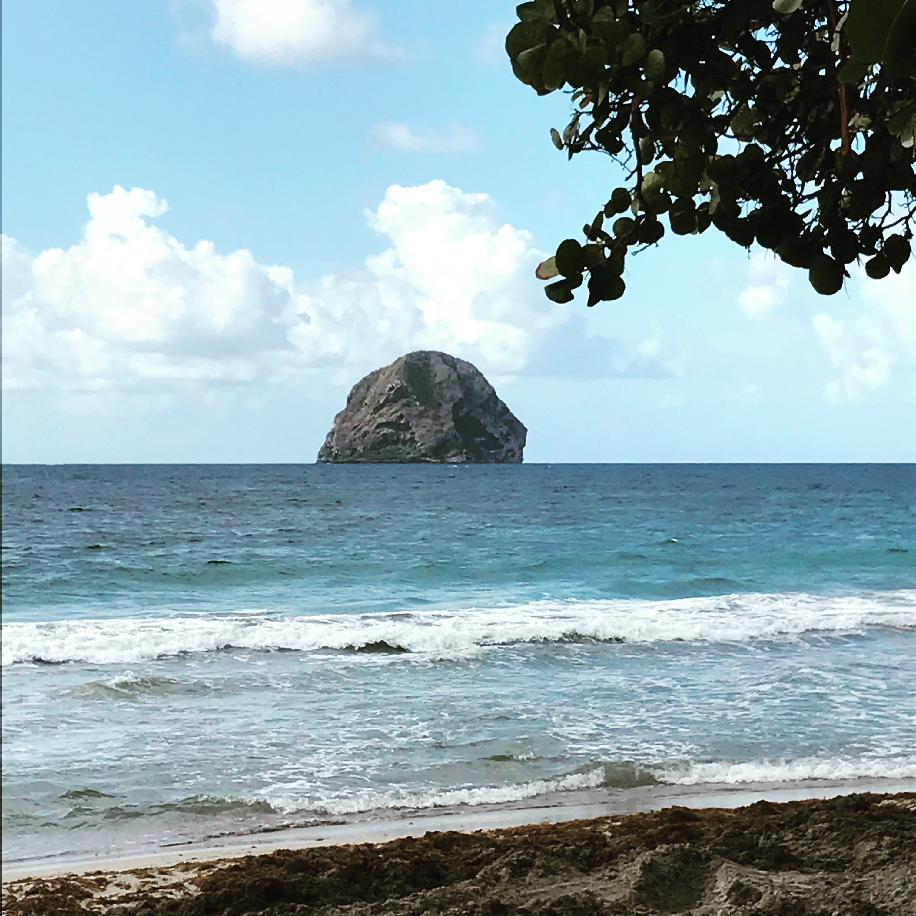
What I remember the most fondly are the memories of their unique beaches, the Rocher du Diamant, the black sand, the local markets and products, the lush vegetation, the beautiful mix of French and Creole languages being spoken, and the mix of cultures. And perhaps the most beautiful part of it all is that they accept and embrace their history. They were colonized, yes, but thanks to the voices of Césaire, Glissant, Fanon, Zobel, Condé, and many others, they are able to look beyond to a place where cultures don’t clash, but instead, harmonize. And the Édouard Glissant Colloquium at the Université des
Antilles made this abundantly clear.
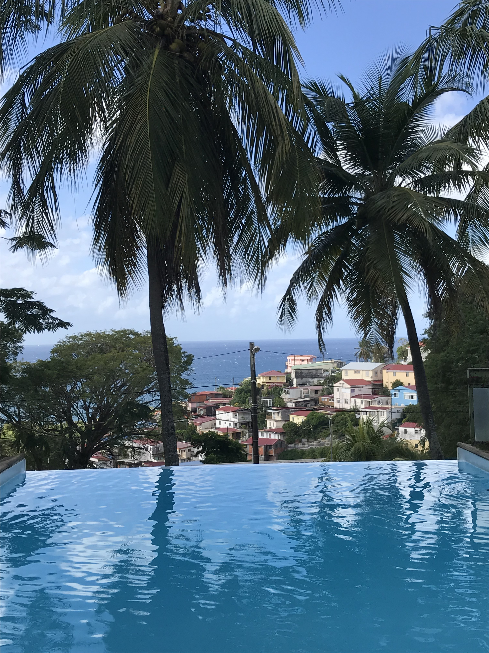
The colloquium provided us with a week of adventures, traveling, cultural experiences, education, and contact with people from all over the world. It was amazing to see people from
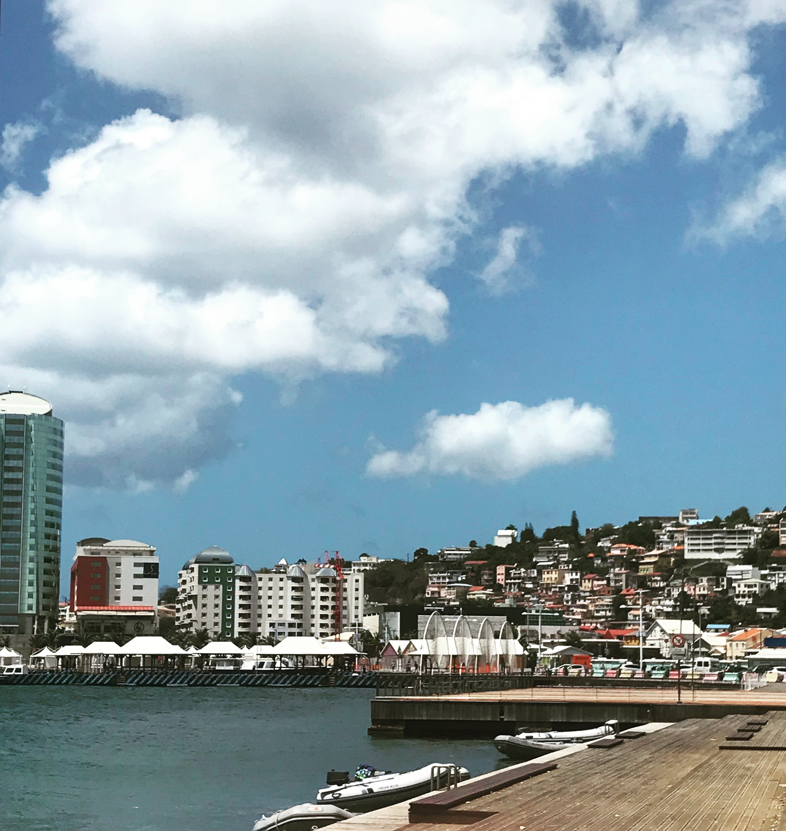
all over the world interested in subjects that we can only talk about inside our own small department in Louisiana. It was refreshing to know that the importance of these strong voices in the French Antilles’ history are being appreciated and recognized.
Martinique and Guadeloupe were both stunning visually, culturally, and educationally. It was an experience I am eternally grateful for and 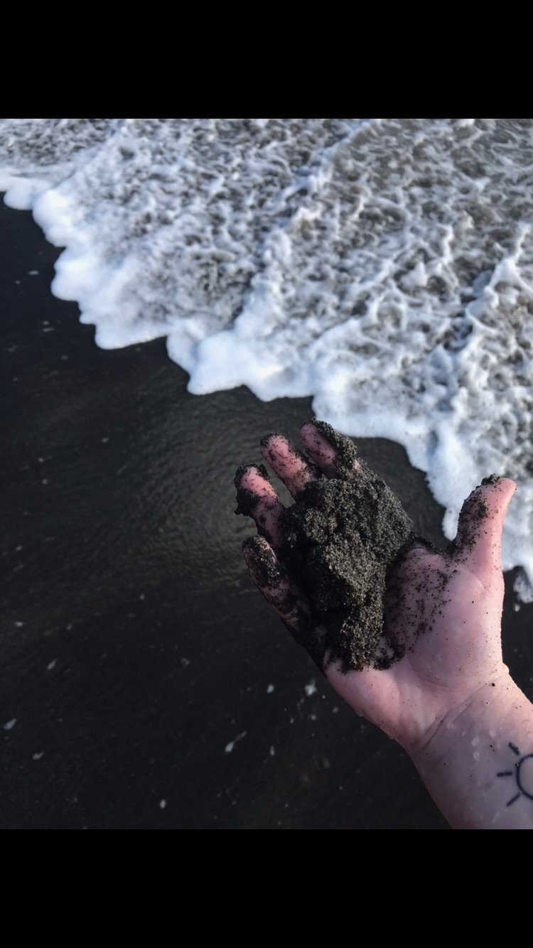
one that I won’t forget.

